Administrative: Unit Change
Office of the registrar
user instructions
Table of Contents
PROCESS 2
ORDER OF APPROVERS 2
INSTRUCTIONS 3
Completing the Proposal 3
Launching the Proposal 6
CONTACT 8

PROCESS
The proposal is used by the Registrar’s Office to process administrative changes to a unit. Changes may include an updated name of a center, college, department, institute, or degree program.

ORDER OF APPROVERS

Approval Process Key:

Approval Stages | Implementation Stage | Review

INSTRUCTIONS

Completing the Proposal
- Login to Curriculog using your net ID and password. https://augusta.curriculog.com

- Select “New Proposal” from the task menu.
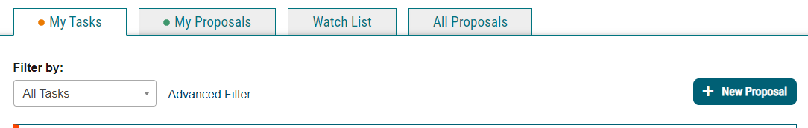

- Hover over the proposal titled “Administrative: Unit Change” and click the blue check mark in order to begin.

- Navigate to the Routing Information section of the proposal.

- Choose the Academic College AND Department by clicking in the field. This will generate a drop down list of all Academic Colleges and Departments. You may only select two options.

- Select the appropriate option regarding The Graduate School.

- Select the appropriate option regarding the department Chairperson.

- Navigate to the Change Information Section.

- Select all of the requested changes that apply.

- Enter the date that these changes will be implemented.

- Select the appropriate options regarding the originating college, department, and old course prefix. Enter the receiving college, department, and new course prefix in the fields below.

- Enter the current name of the Center, College, Department, or Institute.

- Enter the updated name of the Center, College, Department, or Institute.

- Please confirm by selecting the appropriate choice listed below.

- If additional comments are needed, please include those details in the field below.

- Navigate to the Contact Information section.

- Provide the contact information regarding the point of contact for this unit change.

Launching the proposal

- Scroll back to the top of the proposal pane and click the rocket ship icon labeled “Validate and Launch Proposal”. Proposal will be validated and launched.

- The proposal is now in your “My Tasks” tab.

- In order for the proposal to move forward to the next approver step, you must approve it.

- To approve the proposal, click on the proposal on your task list.

- Once the proposal opens, navigate to the right hand menu bar, and select the blue check mark.

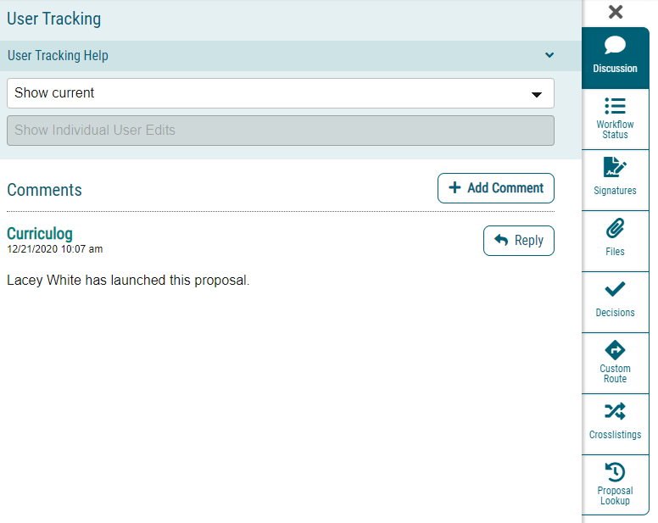

- This will open a discussion box, fill in the radial button beside “Approve” and click “Make My Decision”.
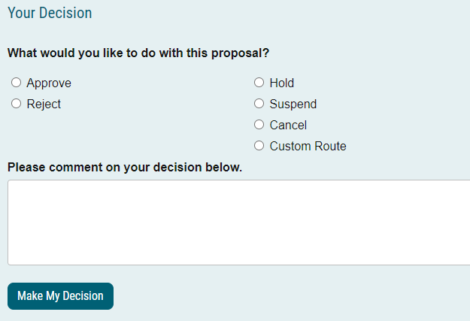

CONTACT
If you have any additional questions, please contact our office at curriculog@augusta.edu.

