# **How to flip forward committees for the 2021-2022 Academic Year**

**Log into your committee account by choosing “Manage Data” and clicking on your Unit’s Committee**

(*We’re using Pamplin as an example below).*

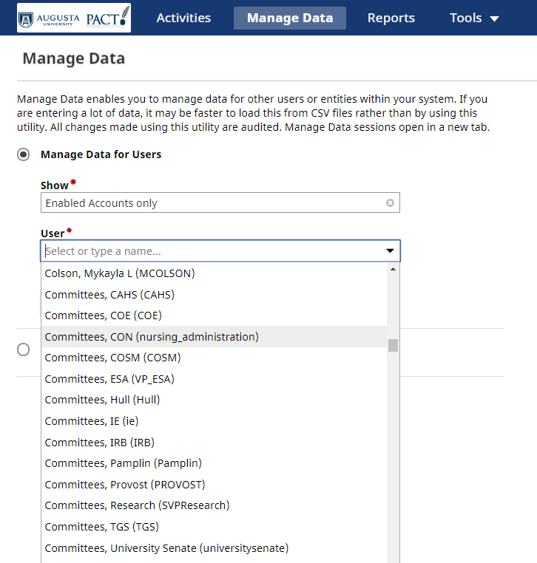

*NOTE: Committees need to be under a committee account and not under a personal account so that the information can continue to be flipped forward even after a person leaves. If you have previously entered committees under and individual’s name, we strongly suggest you move the information over into a generic committee account for your unit. If you don’t have a committee account for your unit, we will be happy to set one up. Contact* [*dmadmin@augusta.edu*](mailto:dmadmin@augusta.edu) *for assistance.*

*At this time, committees are only being recorded at the College level or higher.*

**Choose the AU Committees (Boards or Councils) link.**

*If you do not see this link, please contact* [*DMadmin@augusta.edu*](mailto:DMadmin@augusta.edu) *for access to this screen.*

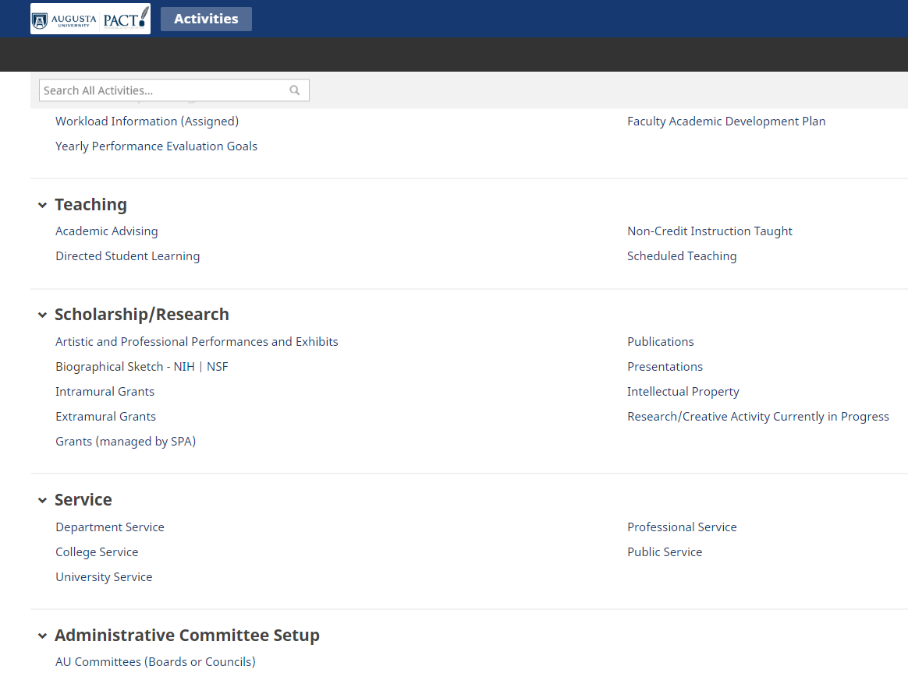

**Click the checkbox to the right of the committee you want to flip forward into the new Academic Year, then click the “Duplicate” button**

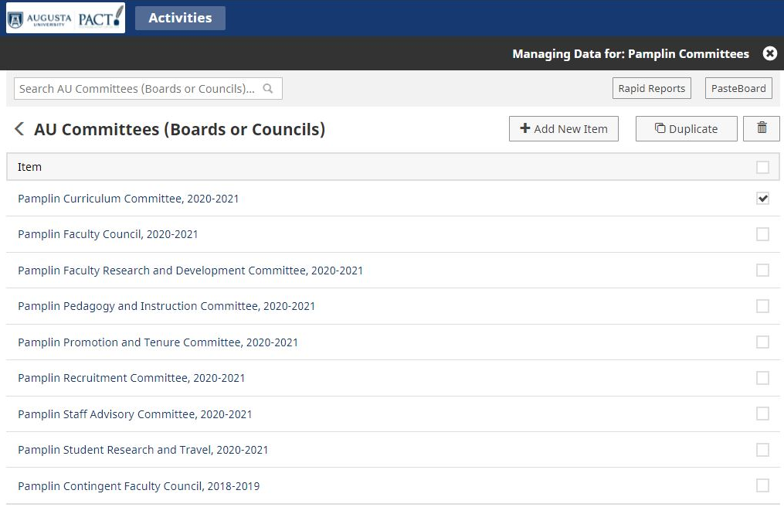

**Change the Academic Year on your copy to 2021-2022, then click Save**

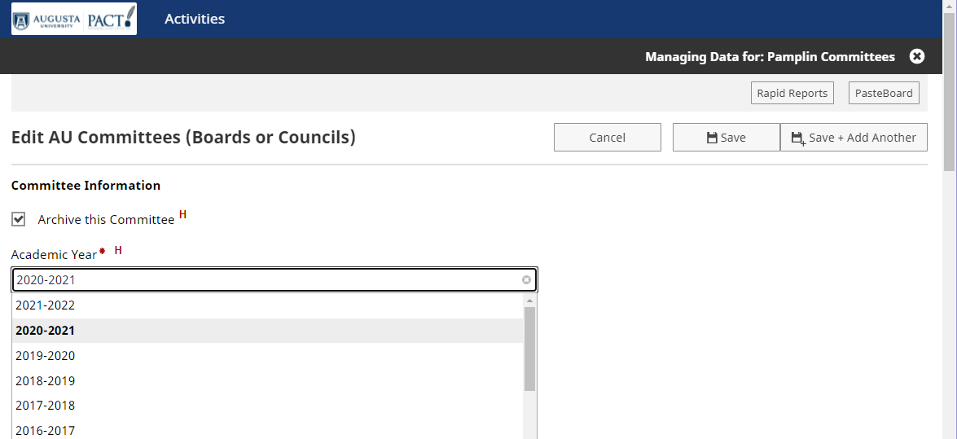

You will now see the committee for the 2021-2022 year. All information, including members will have been copied into the 2021-2022 academic year and can now be edited as needed.

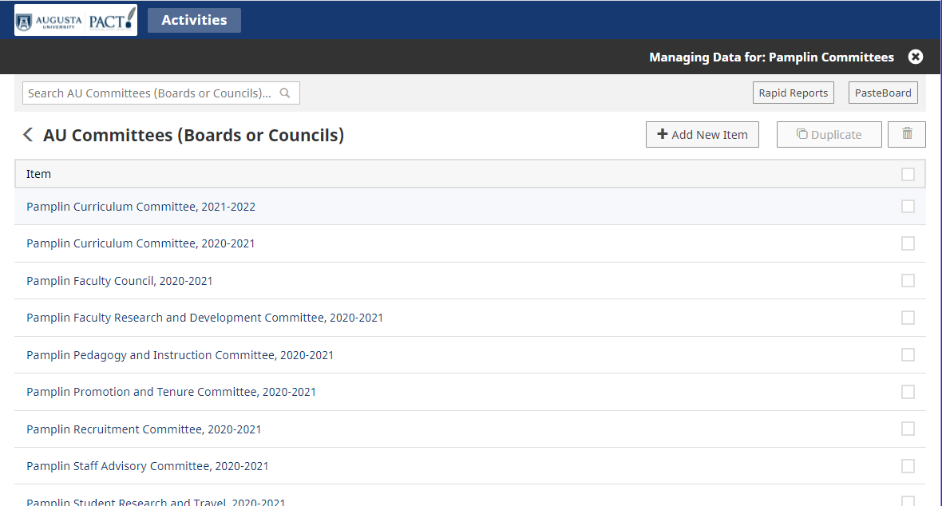

Committee information is automatically displayed on the AU Committee website: <https://www.augusta.edu/committees/>