Normal Testicular Anatomy
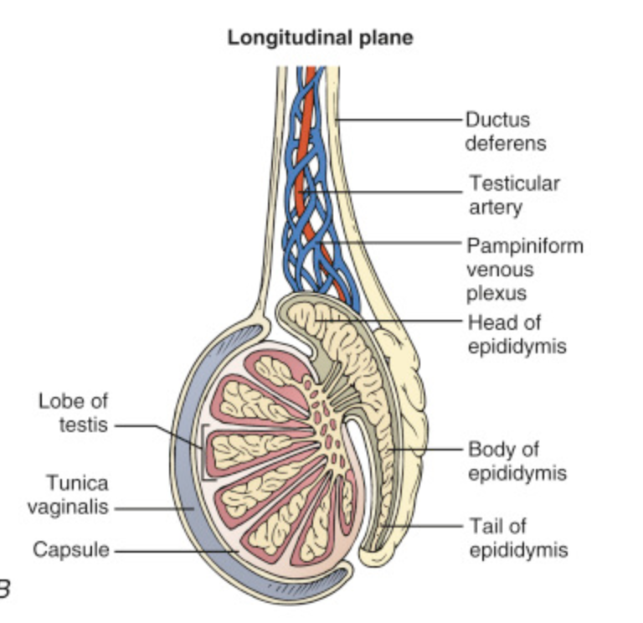

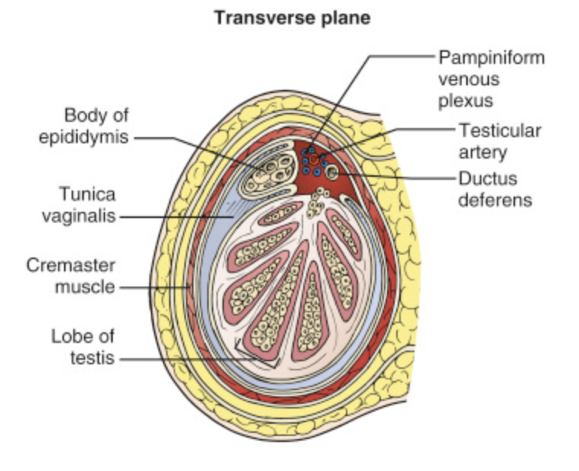

Protocol
- Testicle
  - 2D long axis- with and without color, measurement
  - 2D short axis- with and without color, measurement
  - Pulsed-wave Doppler- arterial and venous flow
  - Buddy shot- with and without color
- Epididymis
  - 2D long axis- with and without color, measurement
  - 2D short axis- with and without color, measurement
  - Color Doppler
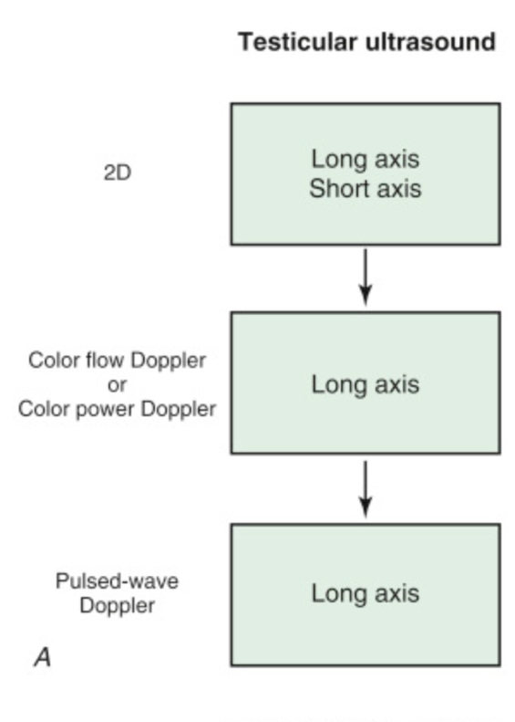

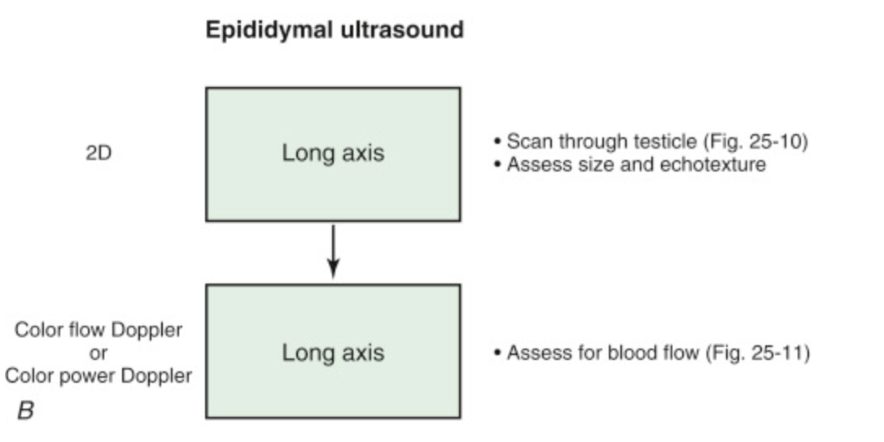
Normal Testicle- Long Axis
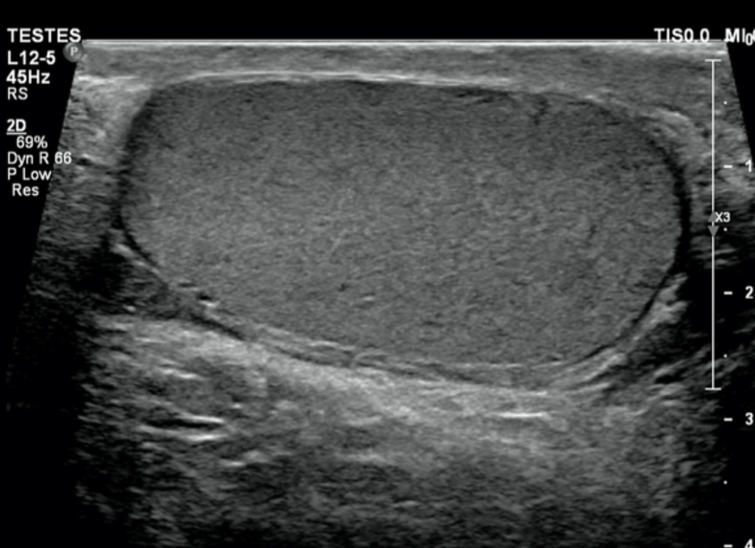

Long Axis Measurement
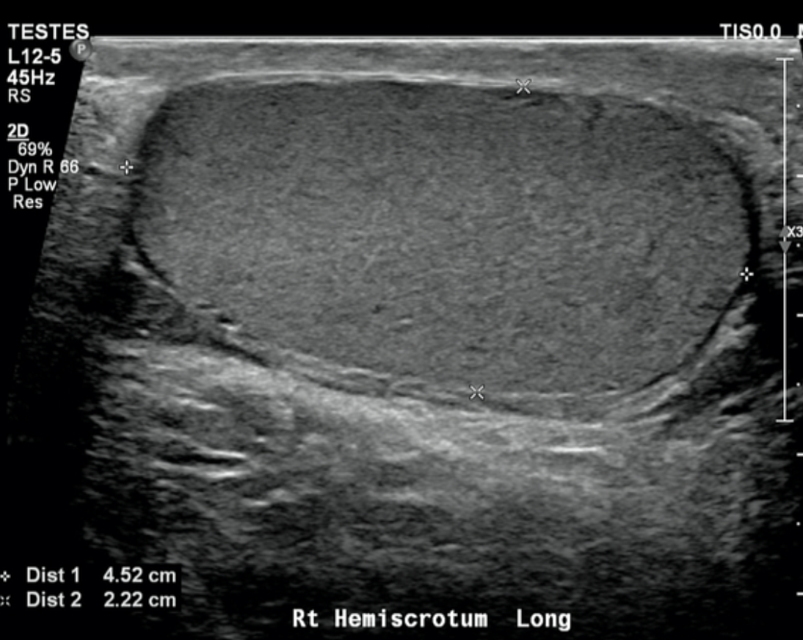

Long Axis with color Doppler
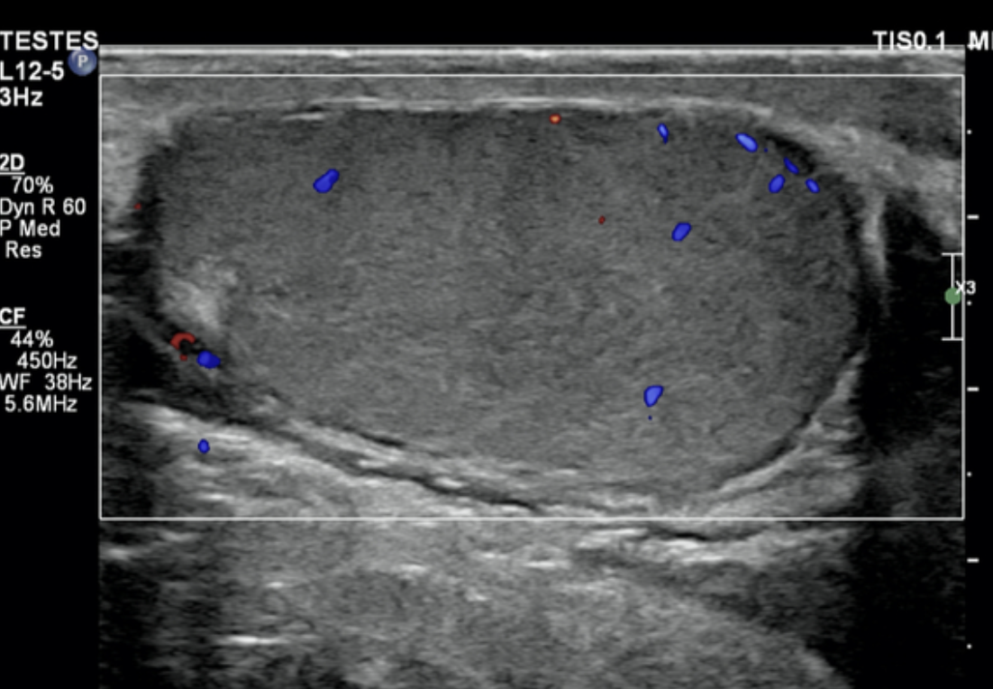

Normal Testicle- Short Axis
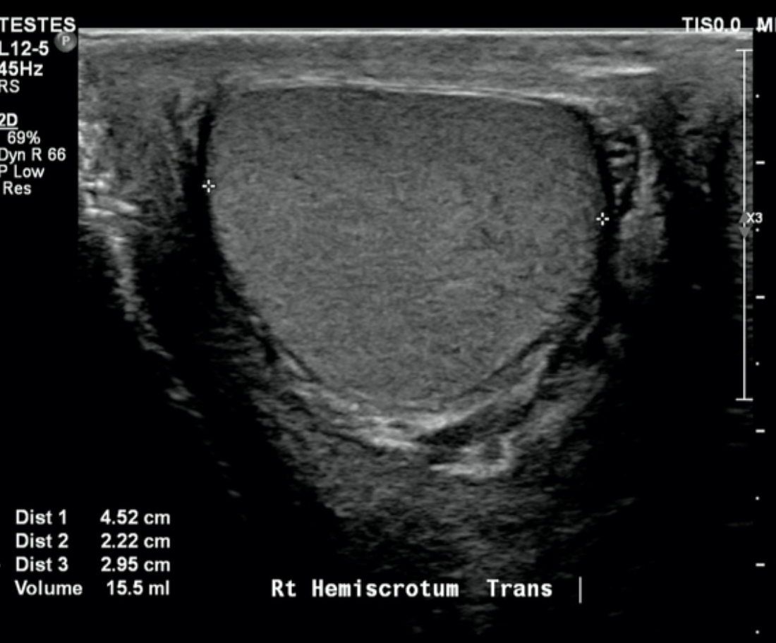

Normal Epididymis- Long Axis
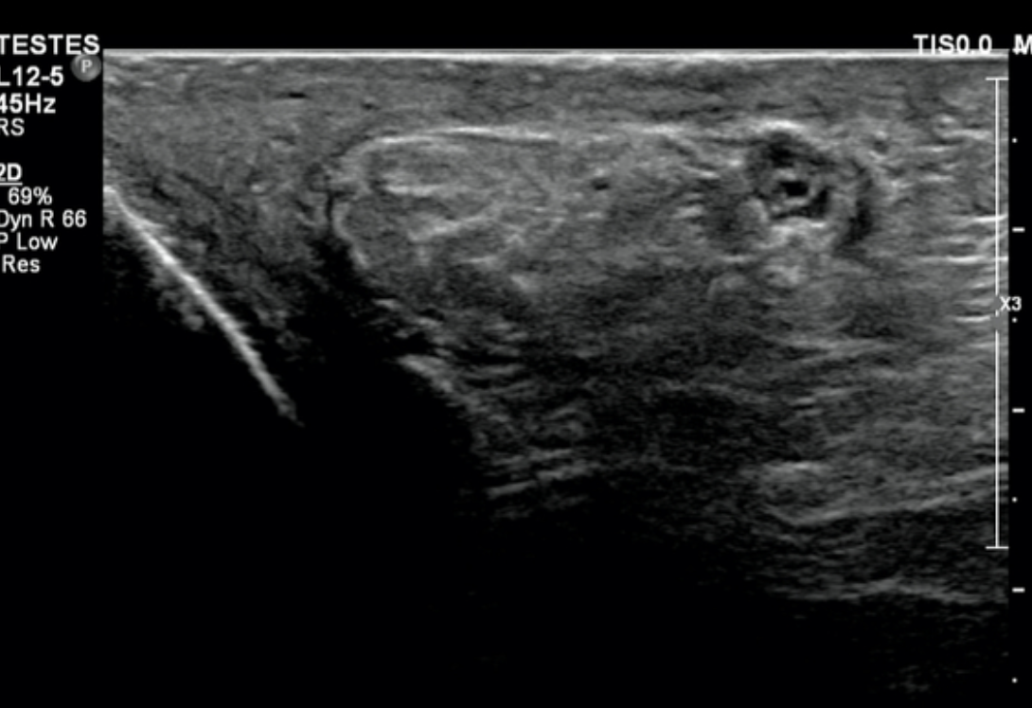

Normal Epididymis- Short Axis
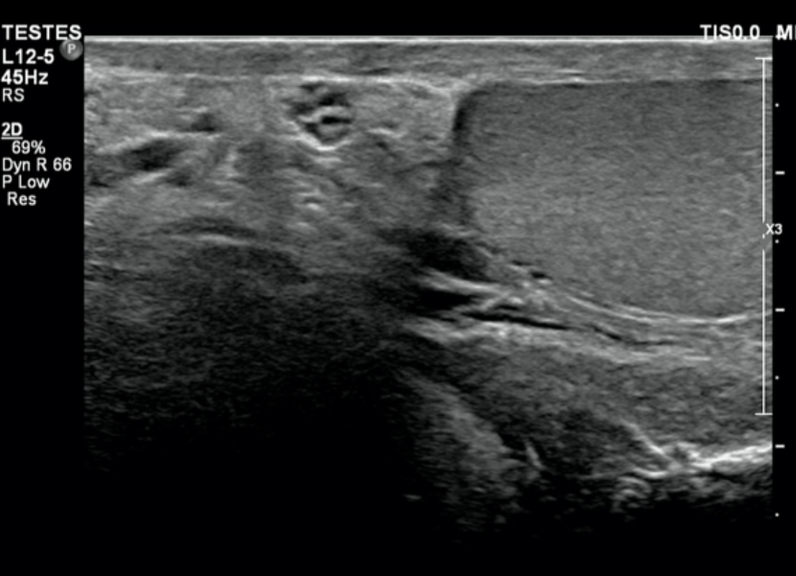

Buddy Shot
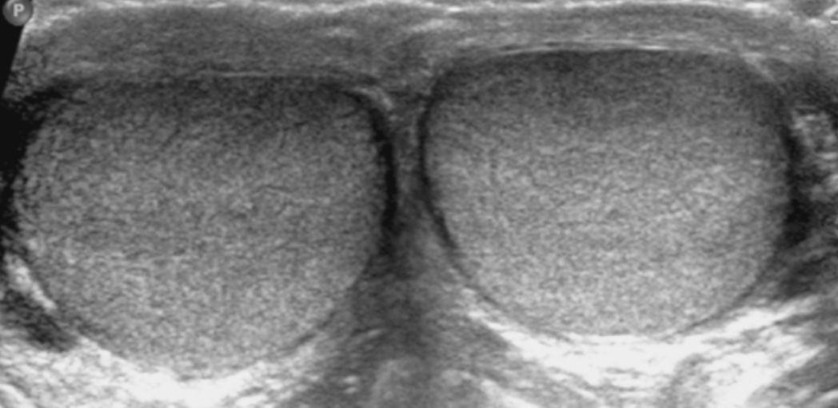

Case Study #1

Patient presents with left testicular pain, redness and swelling.

Sonographic Findings- Left testes enlarged, thickened skin, epididymal tail thickened 10mm, hyperemia, left hydrocele.

Diagnosis- Left Epididymitis

Buddy Shot
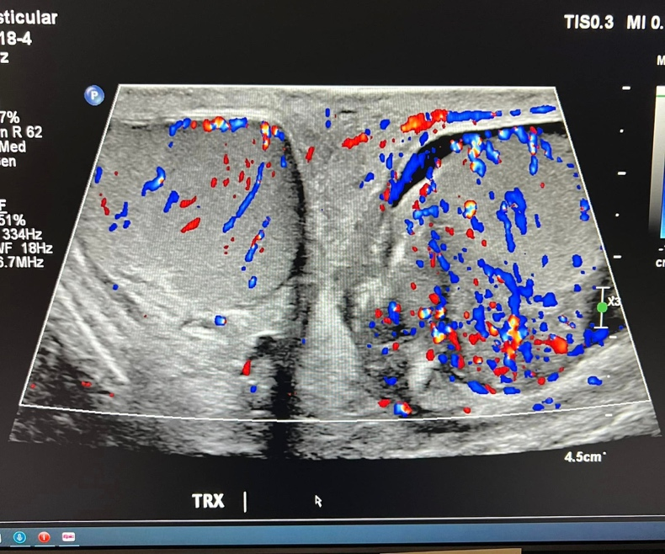

Normal Right Epididymis
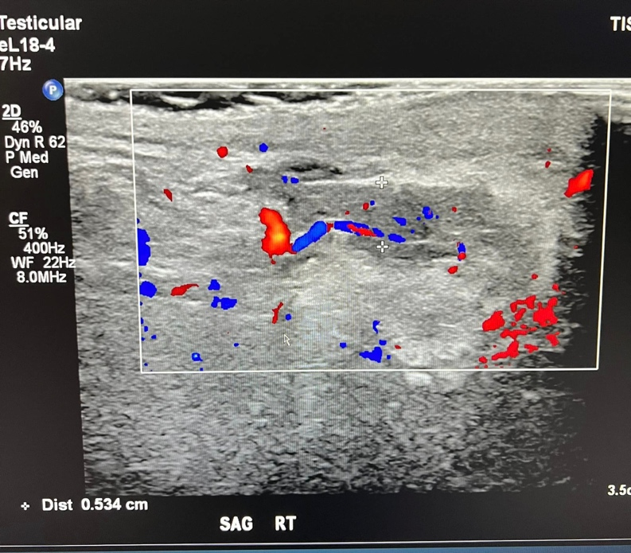

Normal Right Testicle
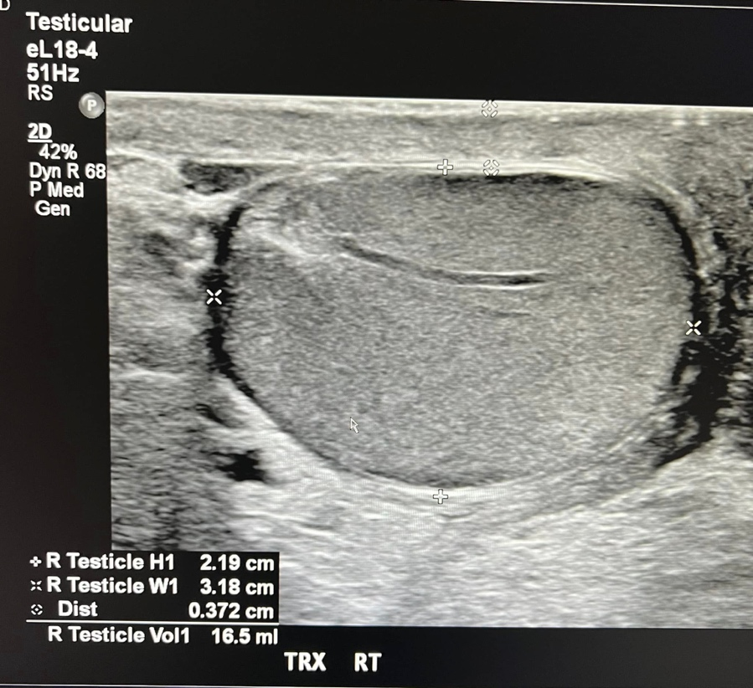

Left Testicle with hydrocele and thickened skin
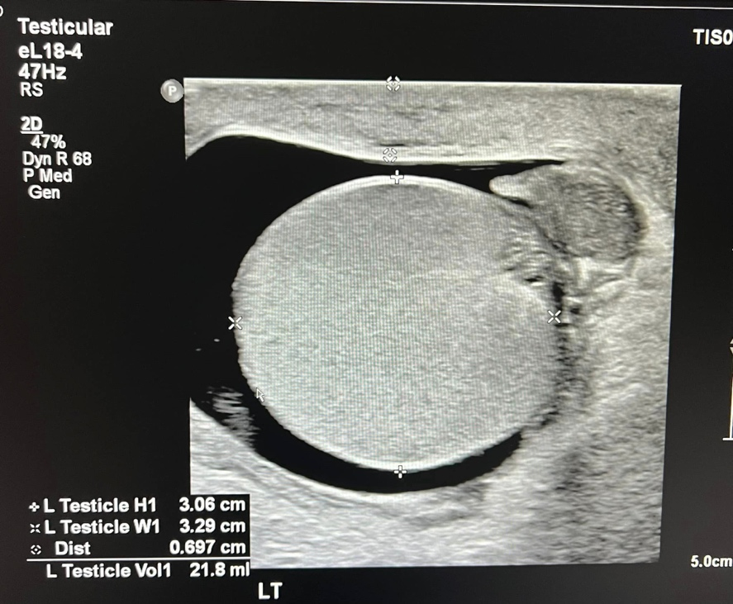

Left Epididymis with increased vascularity on color Doppler
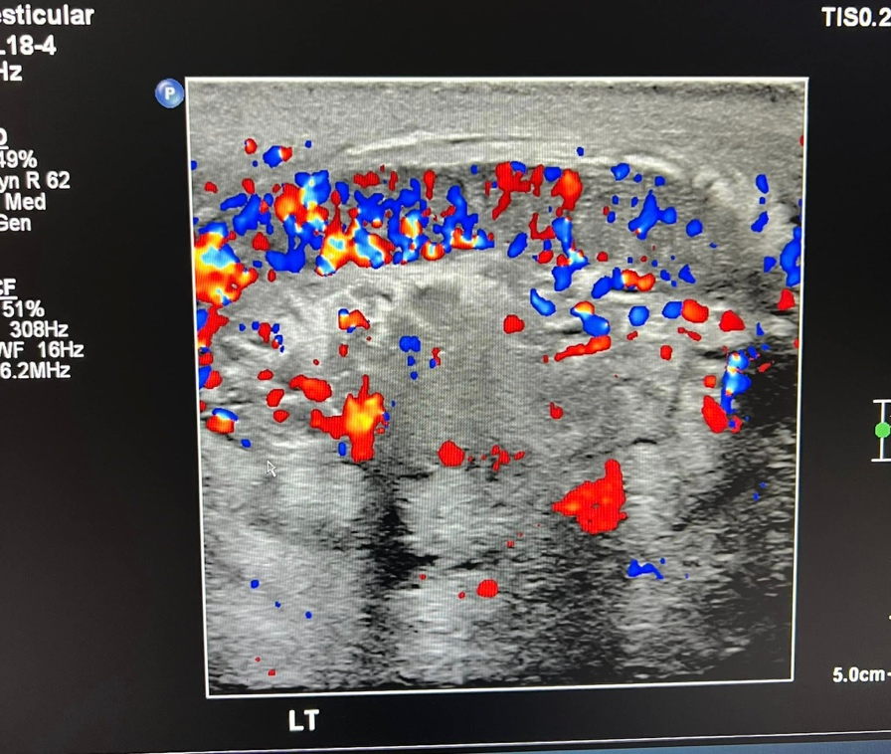

Left Epididymis with increased size
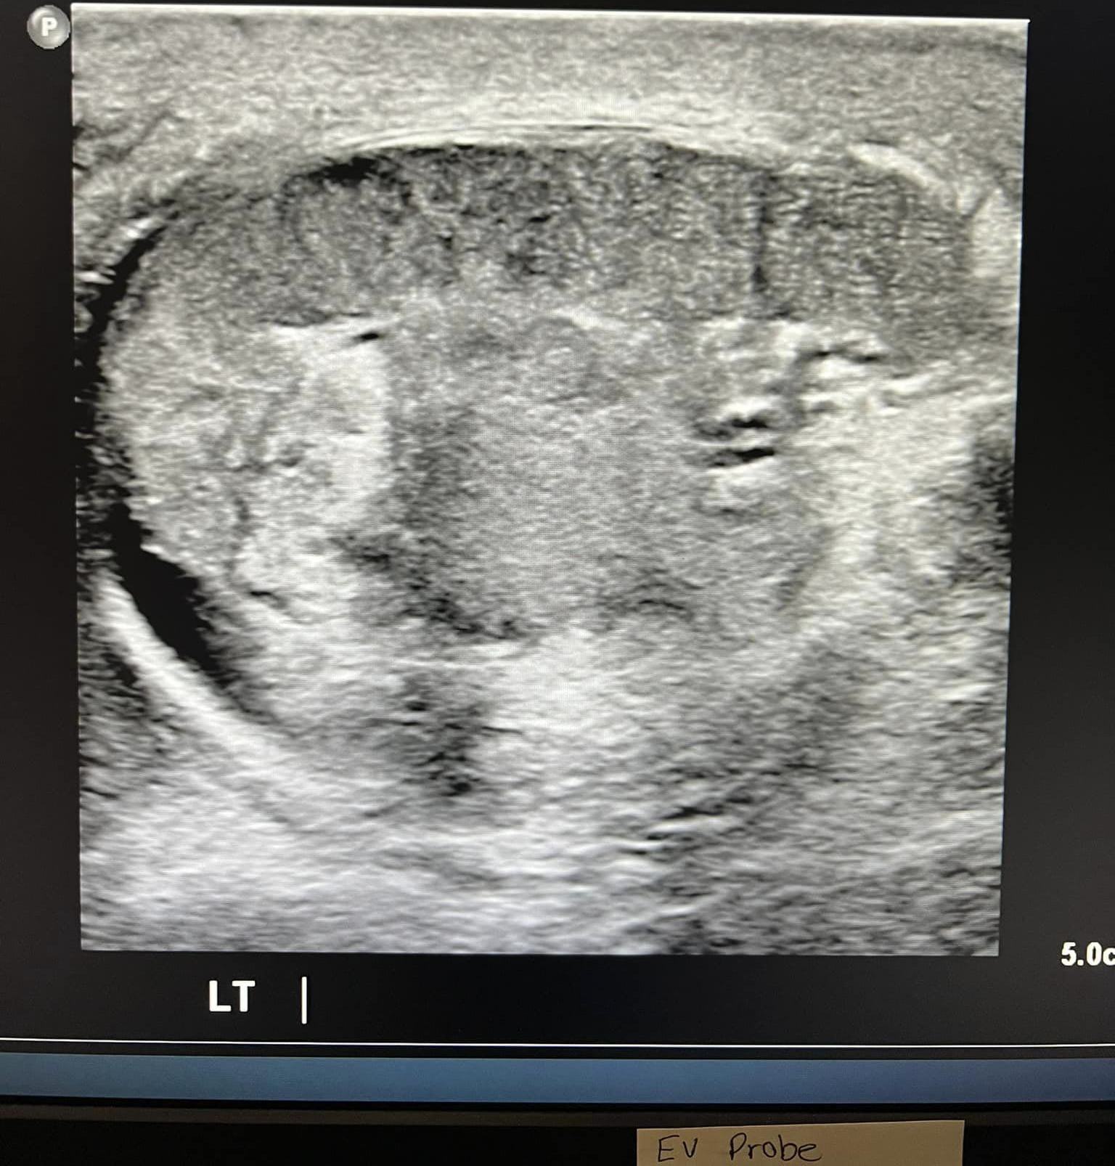

Case Study #2

Patient presents with sudden onset of testicular pain.

Sonographic Findings- Left hydrocele, absence of color Doppler, absence of arterial and venous flow using pulsed-wave Doppler.

Diagnosis- Left testicular torsion. Treatment- Testicle was manually rotated by ER physician until flow returned to the testicle.

Buddy Shot with color Doppler- absence of flow in left testicle, hydrocele
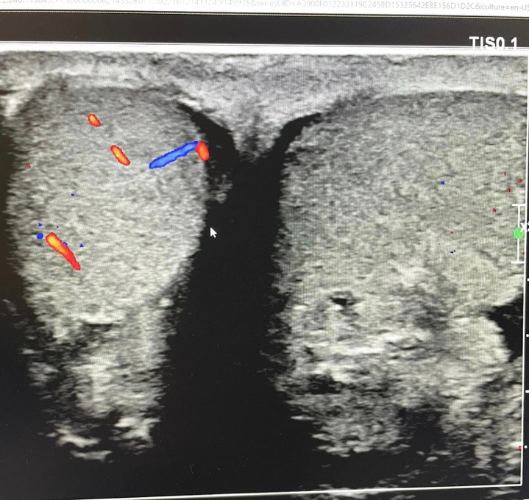

Post manipulation- normal flow visualized in both testicles
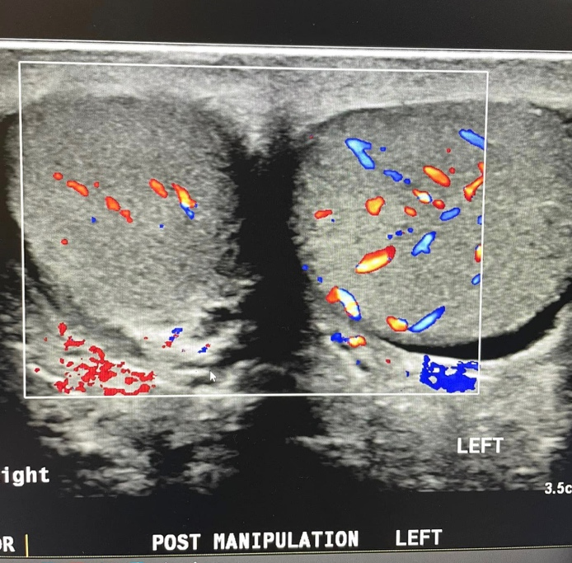
Most manipulation- left testicle,
