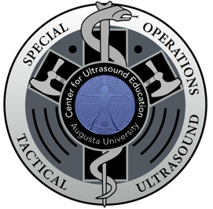

Augusta University

Medical College of Georgia

Center for Ultrasound Education

Registration Information:

Course size is 12 participants with additional participants added in increments of 4.
This allows 2 – 6 participants per instructor.

Training Cost: $1,900 per student

Registration Link

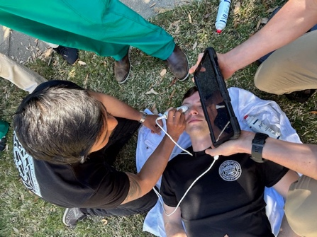
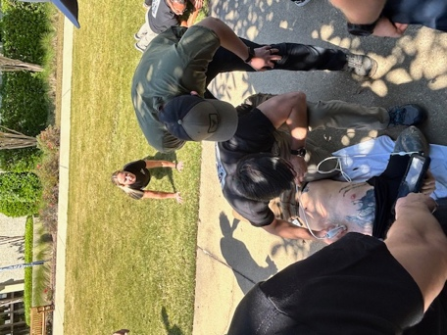

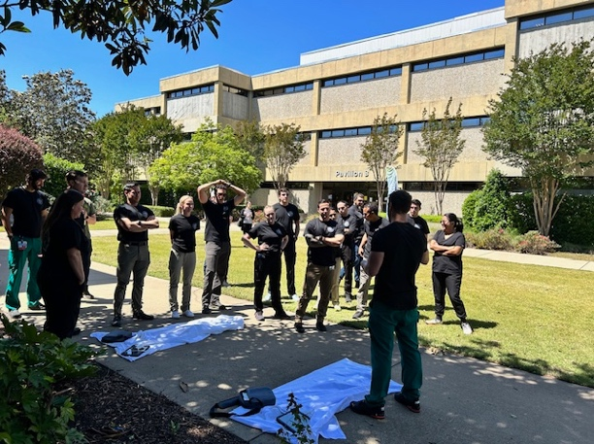

The Augusta University Center for Ultrasound Education in conjunction with the Augusta University College of Medicine (CE) certify that this course, SOT-US, consisting of 32 combined hours of didactic, simulation and live patient ultrasound education, focused on clinical, operational, and tactical integration of point-of care ultrasound into the evaluation of critically ill casualties and patients provides basic competency

