SOTUS Course
March 14-17, 2022
Itinerary

Monday, March 14 | Tuesday, March 15
8:00 – 8:15 Orientation/Coffee  8:15 – 8:30 Pretest  8:30 – 9:15 Lecture:  POCUS in a Tactical and Austere Environment  9:15 – 9:30 Lecture:  FAST Exam  9:30 – 10:30 SP Scanning  10:30 – 11:00 Lecture:  FAST Pathology  11:00 – 12:00 SP Scanning  12:00 – 12:45 Lunch  1:00 – 3:30 ED Scan/Sonosim/Scanning  3:30 – 3:45 Wrap-Up/AAR | 8:00 – 8:05 Orientation/Coffee  8:05 – 8:45 Lecture:  Cardiac Windows and IVC  8:45 – 9:45 SP Scanning  9:45 – 10:30 Lecture:  Putting it into Clinical Context  10:30 – 11:30 SP Scanning  11:30 – 12:00 Lecture:  Thoracic Ultrasound  12:00 – 12:45 Lunch  12:45 – 3:15 ED Scan/Sonosim/Scanning  3:15 – 3:30 Wrap-Up/AAR
Wednesday, March 16  8:00 – 8:05 Orientation/Coffee  8:05 – 8:30 Lecture:  Obstetric Evaluation  8:30 – 11:00 ED Scan/SP Scanning  11:00 – 11:30 Lecture:  Intracranial Pressure/Ocular  11:30 – 12:00 Lecture:  Superficial Ultrasound  12:00 – 12:45 Lunch  12:45 – 1:15 Lecture:  US Needle Guidance for Procedures  1:15 – 2:30 Skills Stations  2:30 – 3:30 Ultrasound PT  3:30 – 3:45 Wrap-Up/AAR | Thursday, March 17  8:00 – 8:05 Orientation/Coffee  8:05 – 8:45 Lecture:  Putting it all Together -- TacFAST  8:45 – 11:30 ED Scan/Sonosim/Scanning  11:30 – 12:00 Q&A, Intro to test  12:00 – 12:45 Lunch  12:45 – 2:00 Testing: Practical & Hands On  2:00 – 2:30 Debrief/Review Cases  2:30 – 3:00 AAR/Q&A/Conclusion

  - Primary POC: Cara Jones – 706-589-2272

Helpful Information
- A map is enclosed that gives you a layout of our location, parking and lunch locations.
- Ultrasound Center – 3rd floor of Pavilion 3, suite 3101.
- Cafeteria – Across the crosswalk on 2nd floor of hospital.
- Student Center Café – Adjacent to the parking area.
- Einstein’s – 1st of the Education Commons

- Badges and N95 masks should be worn at all times.

- Important Phone Numbers
  - Matt Lyon – 706-533-2936 Cara Jones – 706-589-2272
  - Max Bursey – 540-819-8714 Stanton Royer – 706-951-5680
  - AU Police – 706-721-2911 (emergency)

- QR Code for SOTUS Course:
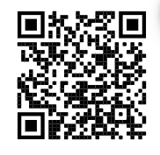
Things to do around Augusta

Workout Options

Hammonds Ferry Park/Dock
Walk toward river from hotel, turn right
Great outdoor grassy area for bodyweight
workouts, paved running path along
river 14-mile round trip length.

Canal Trail
15 miles, scenic dirt bike/run/walk path
Park and enter across from CSRA Humane Society
425 Wood St Augusta, GA
https://augustacanal.com/about.php

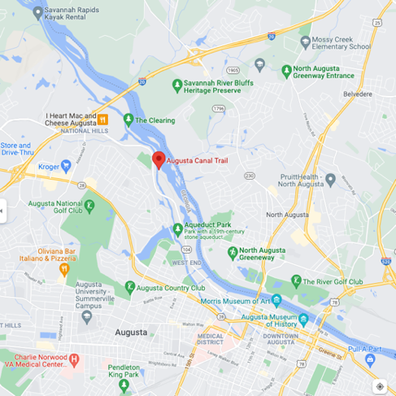
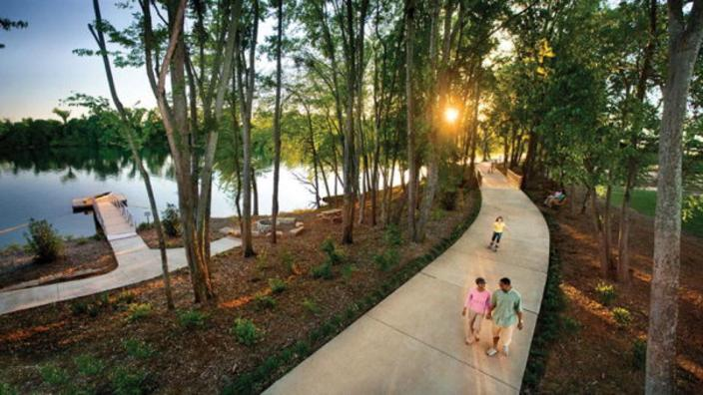

Augusta Aquatic Center
25m swim lanes (closes at 8p) Cost 4$
Damascus Rd, Augusta, GA
Stars and Bars CrossFit
619 E Robinson Ave, Grovetown, GA
20-mile drive, but great gym

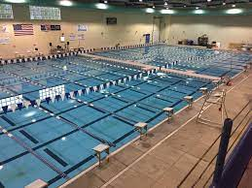
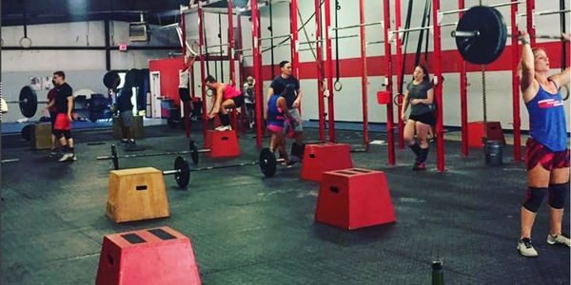

YMCA, Golds Gym, Planet Fitness, Anytime Fitness
All close drive from Hotel in North Augusta, need to be members

Places for Food/Drinks

Southbound Smokehouse
Across from hotel, SW corner of baseball stadium
1009 Center St North Augusta

Broad Street
Walkable with a number of bars & restaurants
Stillwater Taproom, Whiskey Bar, Edgar’s Rooftop, Sole are good spots
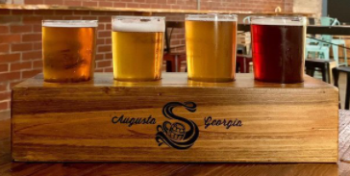
Savanah River Brewing Company
813 5th St Augusta, GA

Riverwatch Brewery
1175 4th St Augusta GA
*Not open on Tuesday

Rio Cantina
Across from Hotel, good food and awesome margaritas

Other things to Do
TopGolf
437 Topgolf Way
Augusta, GA

NorthSide Lanes (Bowling)
1745 Georgia Ave
North Augusta, SC

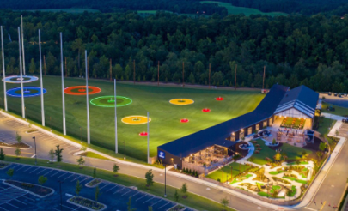
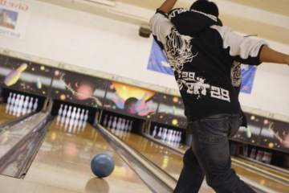

North Augusta Park
Tennis and Basketball- if interested let me know, I have racquets you can borrow.

2nd and Charles
Large, quirky, book, music, games tore across the parking lot from Hooters.
2834 Washington Road, Augusta, GA

Richmond County Library (closes 8p)
823 Telfair St, Augusta, GA

Case 1 Name:
0  Needs significant assistance | 1  Needs some  assistance | 2  Needs little-to-no  assistance

Image 1

0  Needs significant assistance | 1  Needs some  assistance | 2  Needs little-to-no  assistance

Image 2

0  Needs significant assistance | 1  Needs some  assistance | 2  Needs little-to-no  assistance
Image 3

0  No | 2  Yes

Diagnosis
0  No | 2  Yes

Treatment

Evaluator:
Practical Exam Score:
Comments:

Case 2 Name:
0  Needs significant assistance | 1  Needs some  assistance | 2  Needs little-to-no  assistance

Image 1

0  Needs significant assistance | 1  Needs some  assistance | 2  Needs little-to-no  assistance

Image 2

0  Needs significant assistance | 1  Needs some  assistance | 2  Needs little-to-no  assistance
Image 3

0  No | 2  Yes

Diagnosis
0  No | 2  Yes

Treatment

Evaluator:
Practical Exam Score:
Comments:

