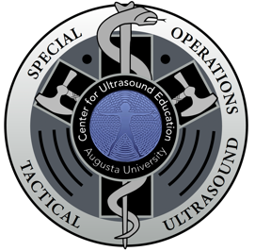
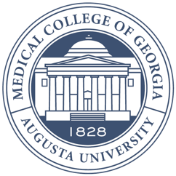
Augusta University

Medical College of Georgia

Center for Ultrasound Education

SOTUS Course
June 20-23, 2022
Itinerary

Monday, June 20 | Tuesday, June 21
8:00 – 8:15 Orientation/Coffee  8:15 – 8:30 Pretest  8:30 – 9:15 Lecture:  POCUS in a Tactical and Austere Environment  9:15 – 9:30 Lecture:  FAST Exam  9:30 – 10:30 SP Scanning  10:30 – 11:00 Lecture:  FAST Pathology  11:00 – 12:00 SP Scanning  12:00 – 12:45 Lunch  1:00 – 3:30 ED Scan/Sonosim/Scanning  3:30 – 3:45 Wrap-Up/AAR | 8:00 – 8:05 Orientation/Coffee  8:05 – 9:00 Lecture:  Cardiac Windows and IVC  9:00 – 10:00 SP Scanning  10:00 – 11:00 Lecture:  Putting it into Clinical Context  11:00 – 12:00 SP Scanning  12:00 – 12:30 Lecture:  Thoracic Ultrasound  12:30 – 1:15 Lunch  1:15 – 3:45 ED Scan/Sonosim/Scanning  3:45 – 4:00 Wrap-Up/AAR
Wednesday, June 22  8:00 – 8:05 Orientation/Coffee  8:05 – 8:50 Lecture:  Obstetric Evaluation  8:50 – 11:15 ED Scan/SP Scanning  11:15 – 11:45 Lecture:  US Needle Guidance for Procedures  11:45 – 12:15 Lecture:  Superficial Ultrasound  12:15 – 1:00 Lunch  1:00 – 1:30 Lecture:  Intracranial Pressure/Ocular  1:30 – 3:00 Skills Stations  3:00 – 4:00 Ultrasound PT  4:00 – 4:15 Wrap-Up/AAR | Thursday, June 23  8:00 – 8:05 Orientation/Coffee  8:05 – 9:00 Lecture:  Putting it all Together -- TacFAST  9:00 – 9:15 Lecture:  Non-Trauma FAST  9:15 – 11:15 ED Scanning/Scanning/Testing  11:45 – 12:00 Lunch  12:00 – 2:00 ED Scanning/Scanning/Testing  2:00 – 2:15 Debrief/Review Cases  2:15 – 2:30 AAR/Q&A/Conclusion

