Actions | Male | Female | Done
1 | Massive Hemorrhage - Tourniquet | Airway – Poor Respiration - BVM
2 | Airway – Poor Respiration - BVM | C-Collar/Spine Stabilization
3 | C-Collar/Spine Stabilization | Vascular Access (I/O)
3 | Vascular Access (IV – Peripheral) | Vital Signs (Monitor)
3 | Vital Signs (Monitor) | Start Fluids
4 | Start Fluids | Stabilize Fracture
 | Ultrasound | Ultrasound | BONUS
Findings | Pericardial Tamponade | Pregnancy
 | Negative FAST Exam | Positive FAST Exam
Shock (Y/N)
Total Points

FAST – Focused Assessment with Sonography in Trauma
Who: Any blunt or penetrating trauma patient
Any patient with shock (this is part of the RUSH exam)
Any patient with altered mental status
Why: Detects “free fluid” in 3 compartments of the body (fluid is anechoic – black)
What: Free fluid in a trauma patient is presumed to be blood
Where:
Abdominal

Supine patient fluid collects Upright patient fluid collects
in Morrisons pouch in Cul-de-sac (rectouterine)
Hemoperitoneum
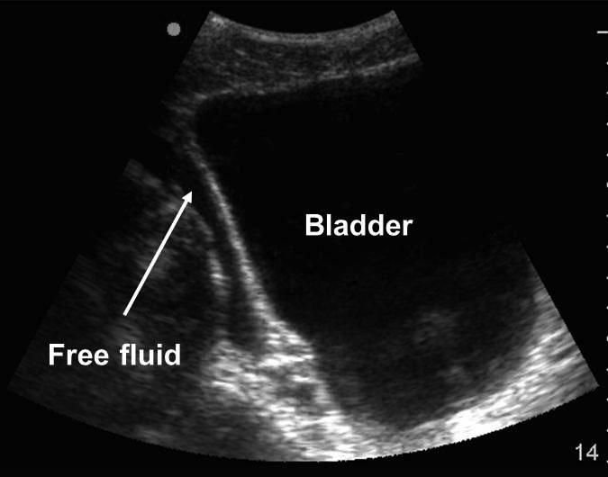
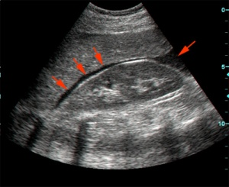

Pericardium

Subxiphoid Apical
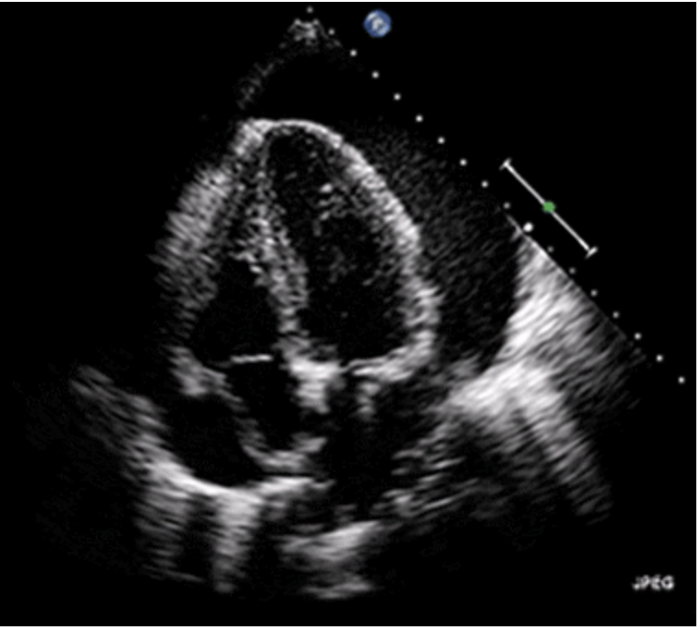
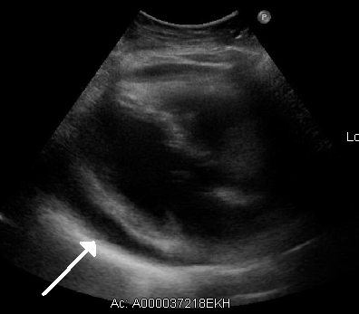
Pericardial Tamponade

Thorax

Right Thorax (RUQ) Left Thorax (LUQ)
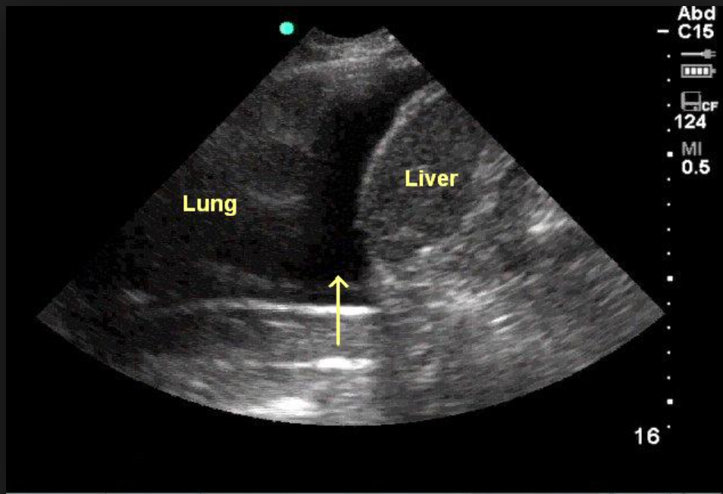
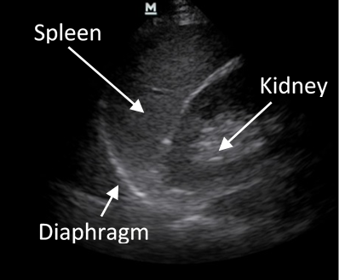
Hemothorax

Retroperitoneal

Cannot Detect Free Fluid In the Retroperitoneum!
IVC

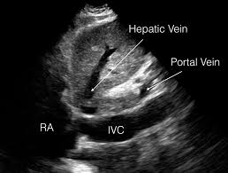
Flat IVC – Hemorrhage Big IVC - Obstruction
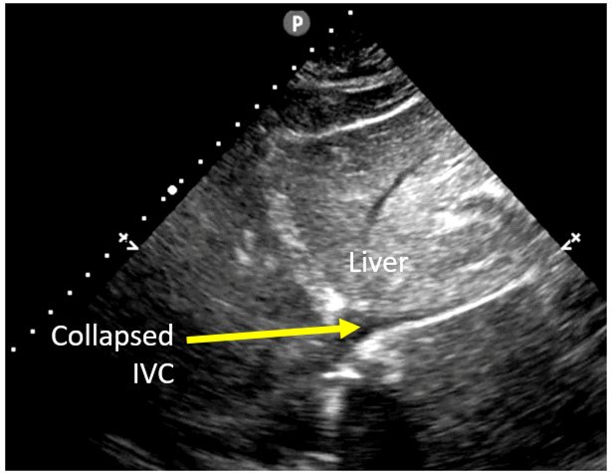
In Shock

Management of Hemorrhagic Shock
- Stop Obvious Bleeding
- Establish a Secure Patent Airway and Optimize Breathing
- Establish IV Access
- Determine the Level Of Conscious (Eyes, Verbal, Motor or GCS)
- Expose the Patient Looking for Injuries (Avoid Hypothermia)

Stage | Pathogenesis | Effects
Compensated Shock | Widespread Vasoconstriction  Fluid Conservation by Kidneys  Stimulation of Adrenal Gland | Tachycardia  Cool Clammy Skin
Decompensated Shock | Pulmonary Hypoperfusion  Tissue Ischemia | Decreased Organ Function  - Decreased Cardiac Output  - Mental Confusion  - Decreased Urine Output
Irreversible Decompensated Shock | Progressive Vasodilation  Increased Vascular Permeability  Pulmonary Hypoperfusion  Anoxic Damage  Hypercoagulability | Hypoxic Encephalopathy  Focused Myocardial Necrosis  Acute Respiratory Distress Syndrome  Acute Tubular Necrosis  Adrenal/Liver Necrosis  DIC  Hemorrhagic Gastroenteropathy

Physical Exam Findings - Stages of Hemorrhagic Shock

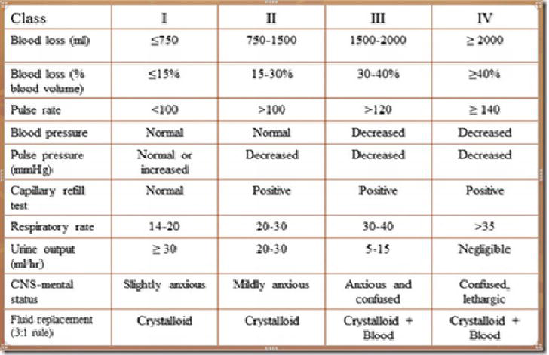

How do concomitant injuries and other factors affect these physical exam findings?
- Neurological Injury (Brain/Spinal Cord)
- Airway Compromise
- Hemorrhagic Shock combined with Obstructive Shock
- Pregnancy
- Not-Obvious Hemorrhage (Intraperitoneal Bleeding and Femur Fracture)
- Age (Chronological and Physiological)
- Sex (Male / Female)
- Body Position
Faculty Watches Simulation
- Let students run as they want to run (20 minutes max)
- When they hook up leads/BP/pulse ox add vital signs
  - Male Female
  - BP 70/50 102/75
  - Pulse 150 125
  - RR 30 25
  - Sat 85% 85%
- End at 20 minutes total (1:20, 2:05)

End of 20 minutes - Debrief
- Team Leader of each team gives brief recap (3 minutes maximuml)
- Group gives 1-3 things went well and 1-3 things went poorly (2 minutes maximum)
- Faculty gives few sentence recap of each case
  - Young male extricated from car wreck with GCS3, obvious amputation. Tourniquet placed, Airway compromised, started BVM, 2 large bore peripheral IV placed and NS bolus started. Placed on monitor, hypotensive, tachycardic, hypoxic. C collar placed, exposure and placed on LSB.
  - Young female extricated from car wreck with confusion but awake, obvious left leg fracture, no external bleeding. Airway compromised, started BVM, Peripheral IV failed, Right Humeral IO placed and NS bolus started. Placed on monitor, hypotensive, tachycardic, hypoxic. C collar placed, exposure and placed on LSB.
  - Tell them that we will discuss the ultrasound component as a group then divide them back into their teams for a case debrief

- Each faculty runs group through what should have happened, remediating procedures as needed. Avoid discussion of ultrasound. Focus on the Jaw Thrust, Bag Valve Mask and creating a seal, and vascular access. (10 min maximum)
  - Procedures
Male Female
Expose/Tourniquet Expose
Jaw Thrust Jaw Thrust
Breathing (BVM) Breathing (BVM)
C Collar C Collar
Circulation (IV) Circulation (I/O)
Disability (has not been covered in curriculum so brief discussion)
Exposure Exposure
Monitor Hook Up Monitor Hook Up
Vital Signs Vital Signs
Identify Shock (tachycardia/Hypotension)
Address Shock IV fluid bolus----------------
Splint leg (femur fracture)
Complete Secondary Survey and Package patient
Ultrasound (As a group 5-7 minutes maximum) Have “ultrasound” person do the imaging
- Start with Female
  - Ask “Why is Morrison’s pouch important?” – It is where free fluid is found in the supine patient
    - Fluid goes down, Air goes up
  - “Where would fluid collect in the upright patient?” – show pelvis window
  - Explain (using handout) that “free fluid” is out of an organ (bleeding) and it outlines organs. In the pelvis show gestational sac and ask “Is this free fluid?”-no, it is a shape – shape is in an organ or structure
  - Then tilt to see fetus
  - Ask “What should the IVC be with blood in the abdomen and thigh causing hemorrhagic shock”?
  - Show Small IVC
- Switch to Male
  - Then ask – “In this patient with obvious hemorrhage and hemorrhagic shock what should IVC be, big or small?”
  - Show IVC – Big dilated – “does not fit”
  - Ask “What kinds of shock have dilated IVC?” – obstructive and cardiogenic
  - Look at heart (subcostal window poor) show pericardial effusion - Ask them if the fluid is “free fluid” – yes as it outlines the ventricles.
  - Explain tamponade quickly

Male Female
RUQ negative positive
LUQ negative negative
Pelvis negative negative/pregnant
SubC not readable negative
Apical pericardial effusion negative
ParaS pericardial effusion negative
IVC dilated flat
Shock Hemorrhagic Hemorrhagic
Obstructive

