Center for Ultrasound Education (CUE)

Medical College of Georgia Augusta University

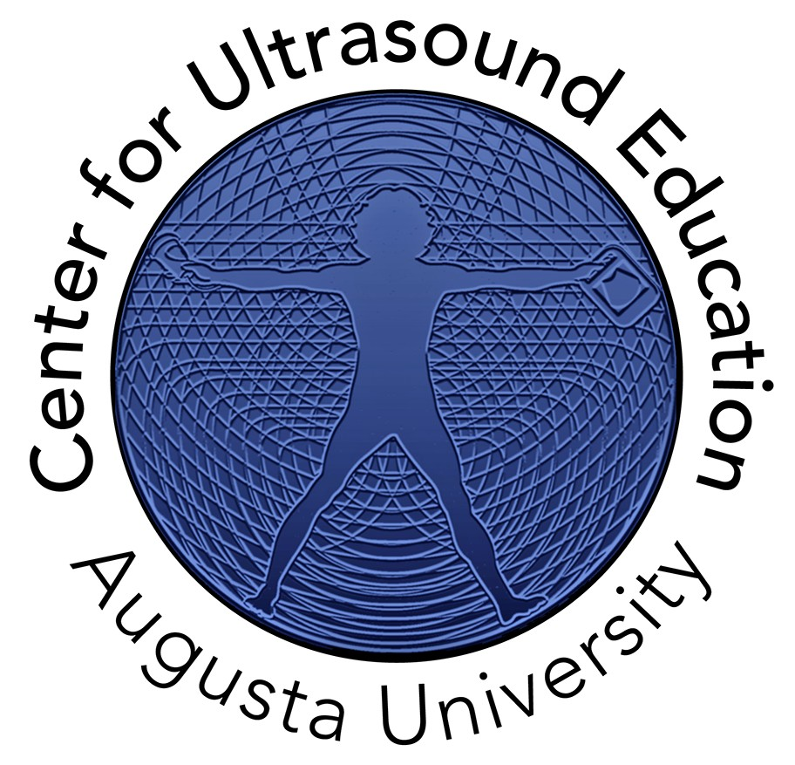Annual Report 2016 – 2017

Acknowledgements

The Center for Ultrasound Education (CUE) is supported by the Medical College of Georgia (MCG) at Augusta University. The scholarship and educational programming conducted would not be possible without Dr. David Hess, Dean of MCG, and Dr. Paul Wallach, Vice Dean of MCG. Through their commitment to educational excellence, the Center for Ultrasound Education continues to pursue the advancement of educational best practices.

Table of Contents

Message from Vice Dean 3
CUE Overview 4
CUE Leadership, Faculty, and Staﬀ 7
CUE Aﬃliate Faculty 8
CUE Advisory Committee 9
CUE Highlights from 2016-2017 10
CUE Overall Instructional Activities for 2016-2017 11
UME Ultrasound Curriculum 2016-2017 11
GME Ultrasound Curriculum 2016-2017 12-13
Resident Ultrasound Labs ………………………………………………………………………………………………………………. 14--18

Message from Vice Dean
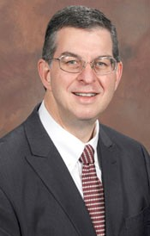Point-of-care ultrasound (POCUS)

is a technology that rapidly is becoming part of high quality patient care in many disciplines. With technology improving and cost falling, it will soon be present in most clinical environments. Hence, it was my goal to bring POCUS into the formal curriculum at the Medical College of Georgia for both medical students and residents. I have been fortunate to be able to recruit an outstanding team of medical educators who
have implemented a bold vision, and have brought to life this Center for Ultrasound Education. Our learners benefit every day from the excellent work of this team. Ultimately, the patients that each learner serves will benefit as well. In particular, I wish to express my thanks to Dr. Matt Lyon (CUE Executive Director) and Becky Etheridge (CUE Director of Ultrasound Education) for their outstanding leadership.

Sincerely,

Paul M. Wallach, MD

Vice Dean for Academic Affairs

Leon Henri Charbonnier Endowed Chair in Medicine

CUE Overview

A pilot point-of-care ultrasound curriculum for medical education was initially developed for Medical College of Georgia (MCG) medical students in the 2013-14 academic year through the support of faculty and administration in the Office of Academic Affairs at MCG. Beginning in Fall 2015, medical students in all years of the curriculum participated in a variety of point-of- care ultrasound instruction labs relevant to their respective curriculum. In July 2016, a point-of- care ultrasound curriculum for graduate medical education was implemented. The undergraduate and graduate medical education activities was formally established as the Center for Ultrasound Education (CUE) in September 2017 by Dr. Gretchen Caughman, Augusta University Executive Vice President for Academic Affairs and Provost.

The Vision of the center is to be an internationally recognized leader of ultrasound education and research for undergraduate, graduate, and continuing medical education.

The Mission of the center is to provide for the advancement and integration of clinician- performed ultrasound in education and research throughout each stage of medical education in order to improve the quality of medical education and practice, while also providing quality cost-effective patient care.

Further, clinicians of varying training backgrounds (nurse, physician, physician assistant, nurse practitioner) and various specialty foci (Medicine, Surgery, OB/GYN, Emergency Medicine) will work in unison for a common understanding of anatomy, physiology, and clinical medical practice. These skills are necessary requirements for the 21st century practice of medicine.

The Goals of the center are defined by training level.

Initial stages of medical training: MCG UME 1st – 2nd year

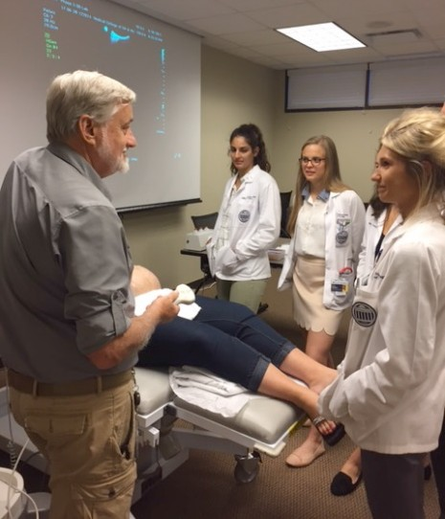Ultrasound Technology as a Clinical Skills Tool. Ultrasound technology will support the basic science content by demonstrating anatomy, anatomical relationships and physiology not possible by any other means. Since ultrasound is a non-invasive technology, structures and anatomical relationships of structures can be demonstrated in living subjects along with dynamic physiological responses to external and internal stimuli. This advances the learners knowledge by allowing them to explore these
relationships in a dynamic way, not possible in any other format. This allows for a curriculum to be developed which is unique, based on self-discovery of basic principles. Other programs, such as PA and DNP, would have similar needs and interests.

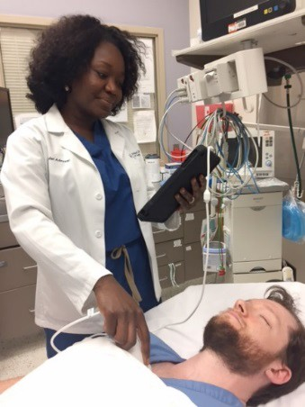Later stages of medical training: MCG UME 3rd-4th year, DNP 2nd-3rd year, PA 2nd Year Ultrasound Technology to Enhance the Physical Exam. Ultrasound will continue to be used to enhance the physical exam skills of the learner. Ultrasound
will allow for visualization of anatomic structures and pathology which helps the clinician develop physical exam skills without ultrasound technology. This type of real-time correlative learning is not possible using any other technology. Ultrasound examination during clinical encounters will allow for evaluation of pathological states, helping the learner understand diagnostic regimens as well as treatment options.

Graduate Medical Education: Residency & Specialty Training

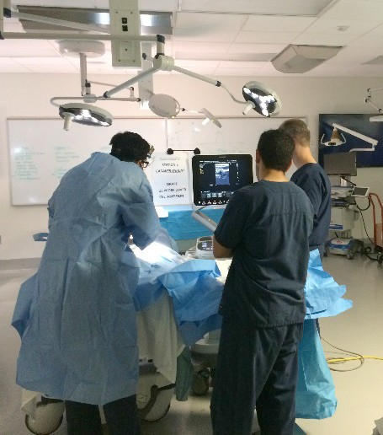Ultrasound Skills as a Core Competency. Clinician performed ultrasound is a core competency needed to fulfill ACGME requirements for many residency and fellowship programs. Ultrasound skills at this level include 3 components: Ultrasound Image
Acquisition of normal and pathologic body structures, Image Interpretation of normal and pathologic body structures, and Clinical Integration of the results into differential diagnosis formulation and medical therapy process. Ultrasound skill acquisition provides a scaffolding for understanding core-curriculum topics.

Continuing Medical Education

Ultrasound Skills as Commodity. Ultrasound is a new and evolving tool for medical decision making and diagnosis. These skills have been taught to few clinician graduates of AU programs. Educational offerings with clinician-performed ultrasound as the center are a highly sought after topic for clinicians wanting to improve their medical practice and diagnostic abilities. Ultrasound for CME focuses on both anatomy and physiology as with early stages of medical education but also combines medical decision making skills to the clinicians already developed skills differential diagnosis formulation and testing.

Multi-disciplinary, Multi-specialty Training

Ultrasound Skills are Universal. The ultrasound skills of image acquisition and interpretation are universal. This allows for learners from various training backgrounds, specialties, and practices to training in a group setting. The ultrasound skill of clinical integration is very different among

specialties and training backgrounds. In group settings, clinicians can learn the various approaches to integrating medical knowledge into practice and therapy based on specialty and discipline training. This allows for a better understanding between clinicians as well as allowing for opportunities for team building and coordination of care.

CUE Leadership, Faculty, and Staff

PAUL M. WALLACH, MD, FACP VICE DEAN, ACADEMIC AFFAIRS
LEON HENRI CHARBONNIER ENDOWED CHAIR IN MEDICINE

It is through Dr. Wallach’s vision and planning that the Center for Ultrasound Education has been created and implemented. His guidance and support has enabled the center to accomplish many of its founding goals.

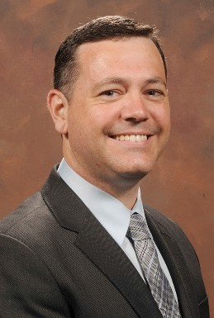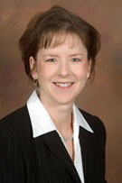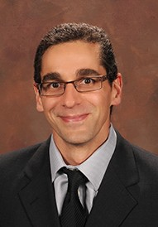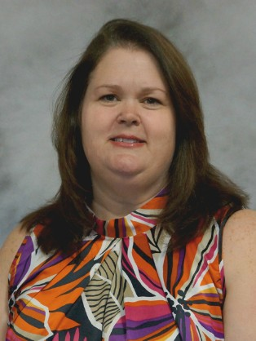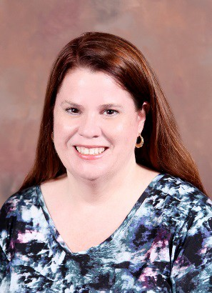Matthew Lyon, MD CUE Executive Director
Becky J. Etheridge, MHE, RDMS Director, MCG US Education
Dan Kaminstein, MD Director, International US

Chela Best, BS, RDMS Assistant Director, MCG US Education
Vicky Wingrove Administrative Assistant

CUE Affiliate Faculty

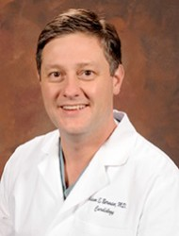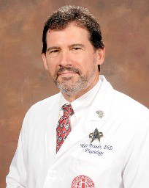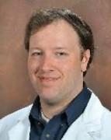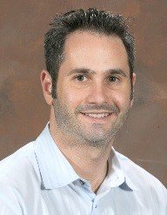Adam Berman, MD Cardiology
Michael Brands, PhD Physiology
Richard Gordon, MD Emergency Medicine
Ryan Harris, PhD Physiology / Pediatrics

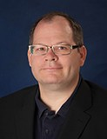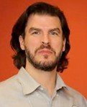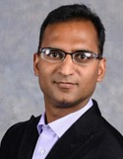Stephen Holsten, MD Surgery
Ted Kuhn, MD Emergency Medicine
Vikas Kumar, MD Anesthesiology
Lee LaRavia, DO Emergency Medicine

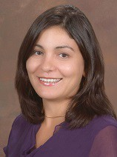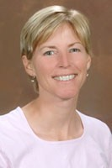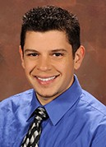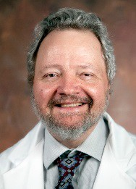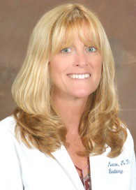Yulia Melenevsky, MD Radiology
Janet Munroe, MD Radiology
Fenwick Nichols, MD Neurology
Alyce Oliver, MD, PhD Medicine

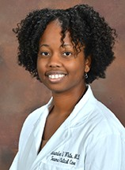Cassandra White, MD Surgery
Eric Zevallos, MD Emergency Medicine

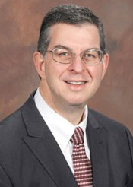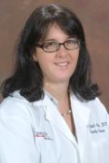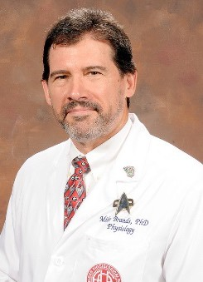CUE Advisory Committee

Paul Wallach, MD Vice Dean
Michael Brands, PhD Physiology
Julie Dahl-Smith, DO Family Medicine
Kevin Dellsperger, MD AU Health CMO

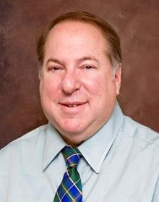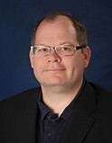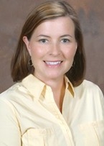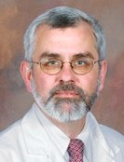Thomas Dillard, MD Pulm / CriScal Care
Arthur Fleischer, MD Vanderbilt University
Stephen Holsten, MD Surgery
Lee Merchen, MD Internal Medicine

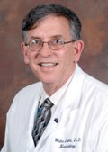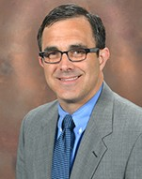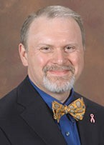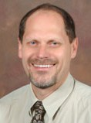Walt Moore, MD Sr Assoc Dean GME
Bill Pearson, PhD Cellular Biology & Anatomy
James Rawson, MD Radiology
Richard Schwartz, MD Chair, Emergency Medicine

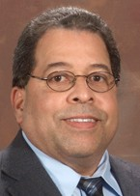Giberto Sostre, MD Radiology
Chris White, MD Pediatrics

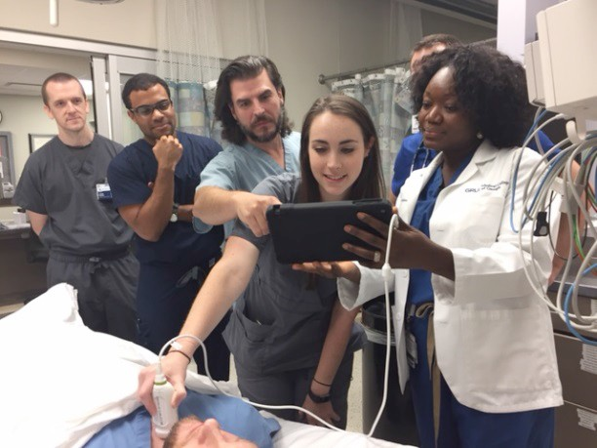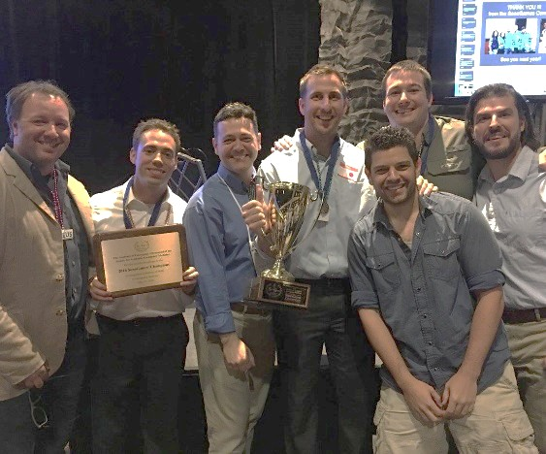CUE Highlights from 2016-2017
Began GME Resident & Fellow Ultrasound Curriculum
July 2016

SonoGames for Emergency Medicine Residents
July 2016

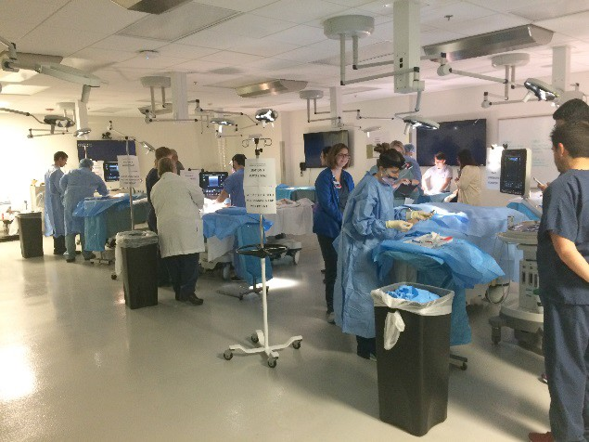DesignaSon by Provost as Center for Ultrasound EducaSon
Central Line Cadaver Competency Course September 2016

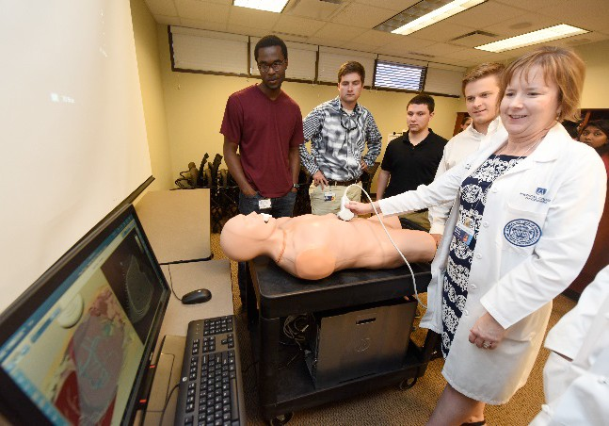November 2016

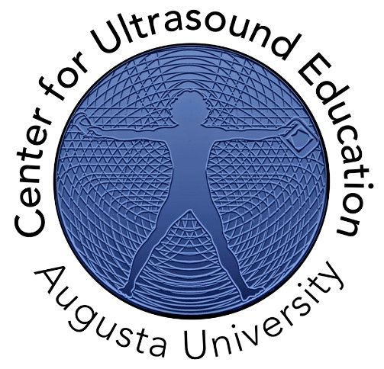

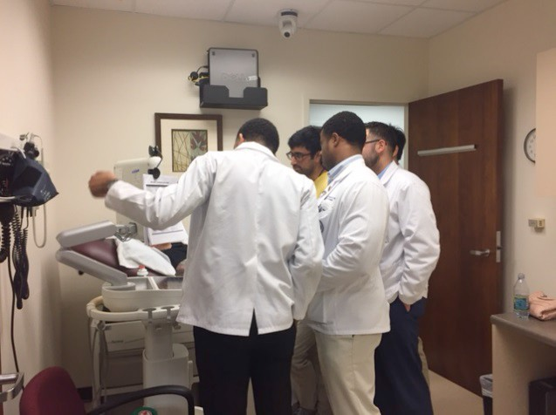

CompleSon of Phase 1, Phase 2, Phase 3 Medical Student Ultrasound Scanning Labs May 2017
Medical Student Physical Diagnosis PracSce, EKG & Spirometry Labs January – March 2017

CUE Overall Instructional Activities for 2016-2017

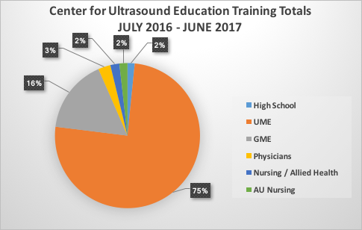The Center for Ultrasound Education developed, planned, and implemented a variety of ultrasound scanning sessions for a wide range of point-of-care ultrasound learners including high school students, undergraduate medical education (UME) and graduate medical education (GME) learners, physicians, nursing and allied health professionals, and AU Health nursing. The total instructional activities for 2016-17 are totaled in the graph below.

UME Ultrasound Curriculum 2016-2017

Phase 1 Year 1 Ultrasound Labs

Lab Module / Content
Intro to US Lab Cellular & Molecular Basis of Medicine / Ultrasound IntroducSon Lab
MSK (Shoulder) Lab Musculoskeletal / Rotator cuﬀ muscles of Shoulder
Cardiac Lab Cardiopulmonary / Subcostal 4 Chamber Heart & Parasternal Long Axis Heart
Abdomen Lab GastrointesSnal / Liver & Right Renal
Pelvis Lab Gynecology / Transabdominal / Endovaginal Pelvis; Intro to Obstetrics
Neck Lab Head Neck Special Senses / Thyroid, Jugular Vein, Common CaroSd Artery

Year Total: 5,022

GME Ultrasound Curriculum 2016-2017

The ultrasound curriculum for the Undergraduate Medical Education (UME) students at MCG consisted of a variety of hands-on instructor supervised scanning labs. The UME phase and content for the labs are listed below. The end of year student evaluation data is also presented in the following chart.

Phase 1 Year 1 Ultrasound Labs

Lab | Module / Content
Refresher to US Lab | Cellular & Molecular Basis of Medicine / Ultrasound Refresher Lab
Abdomen Lab | GastrointesSng / Spleen, Leg Renal, Aorta
MSK Knee Lab | Musculoskeletal / Knee structures
Cardiac Lab | Cardiopulmonary / Parasternal Short Axis, Apical 4 Chamber
Pelvis Lab | Gynecology / Transabdominal / Endovaginal Pelvis; Intro to Obstetrics
Ultrasound PracOcum Lab | Review / FAST exam

Phase 1 Year 1 Ultrasound Lab Student Evaluations

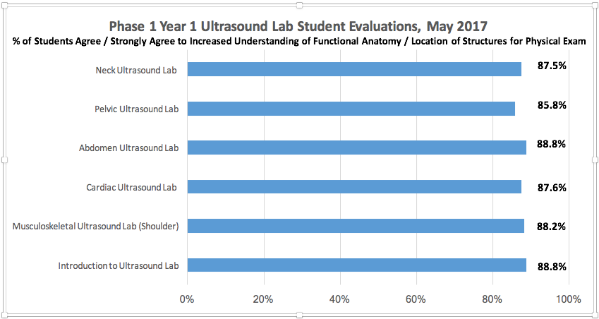

Phase 2 Year 2 Ultrasound Labs

Date | Session | Content
July 2016 | Phase 3 Pre-Clinical Scan Lab | Focused Assessment with Sonography  for Trauma (FAST), Aorta / IVC, Intro  to OB
December / January 2017 | Phase 3 Scanning Labs | Gallbladder, Ultrasound guided  vascular access
July – April 2017 | RADM 5015 | Point-of-care ultrasound elecSve
July – April 2017 | EMED 5008 | Emer Med / ultrasound elecSve

Phase 2 Year 2 Ultrasound Lab Student Evaluations

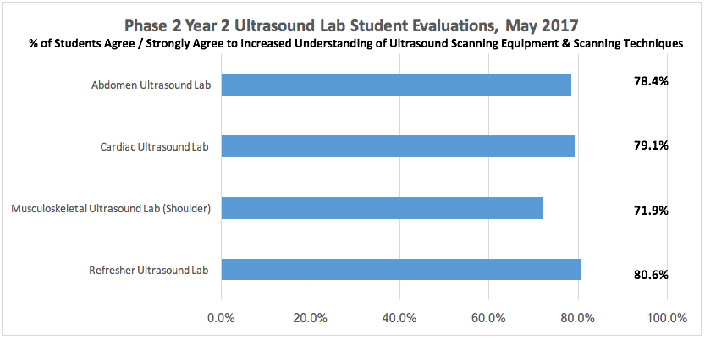

Phase 3 Years 3 & 4 Ultrasound Sessions

Date | Session | Content
July 2016 | Phase 3 Pre-Clinical Scan Lab | Focused Assessment with Sonography for Trauma (FAST), Aorta / IVC, Intro to OB
December / January 2017 | Phase 3 Scanning Labs | Gallbladder, Ultrasound guided vascular access
July – April 2017 | RADM 5015 | Point-of-care ultrasound elecSve
July – April 2017 | EMED 5008 | Emer Med / ultrasound elecSve

The ultrasound curriculum for the Graduate Medical Education (GME) physicians at MCG consisted of a variety of hands-on instructor supervised scanning labs. The GME phase and content for the labs are listed below.

Resident Ultrasound Labs

Lab | Content
July 2016 | Introduction / Focused Assessment with Sonography for Trauma Lab
August 2016 | Sog Tissue Ultrasound Lab
September 2016 | Ultrasound-Guided Vascular Access Central Line Testing Lab
October 2016 | Aorta / Kidney Ultrasound Lab
November 2016 | Cardiac Ultrasound Lab
December 2016 | Gallbladder / Biliary System Ultrasound Lab
January 2017 | Liver Ultrasound Lab
February 2017 | Thoracic Ultrasound Lab
March 2017 | Thyroid Ultrasound Lab
April 2017 | Lower Extremity Venous Ultrasound Lab
May 2017 | Shock Ultrasound Lab
June 2017 | Ultrasound PracScum

“Making Central Lines SAFER” Initiative

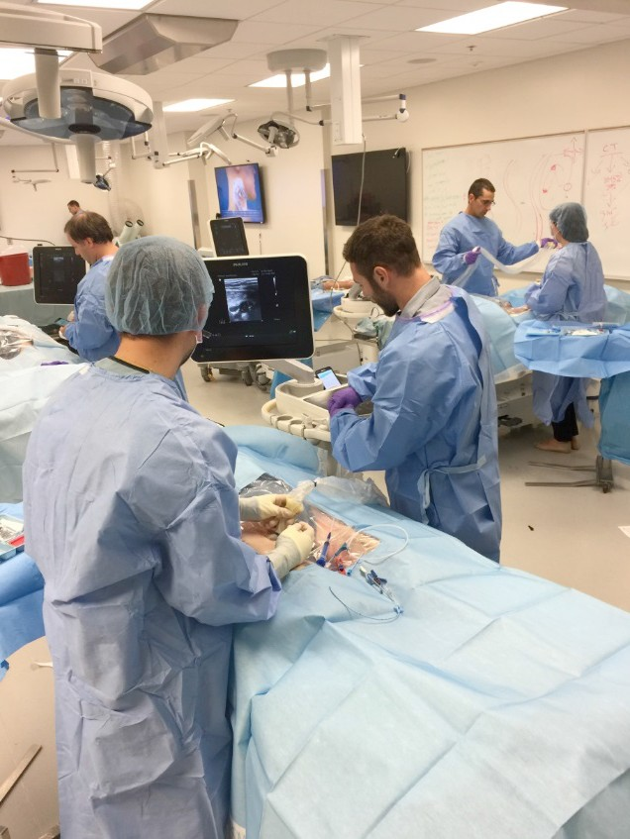The “Making Central Lines SAFER” initiative is a comprehensive Health System-wide program to decrease complications, both mechanical and infectious,
from resident-performed central venous access (CVA). This program was initiated in September 2016 in to address the need for consistent, uniform central venous access technique and training for our GME (Graduate Medical Education) programs. After only one year the Making Central Line SAFER program has had dramatic results, eliminating major procedural complications and drastically
reducing central line associated blood stream infections

(CLABSI). This program has standardized the techniques, equipment, and training for CVA, saving the health system financial resources and patient-complications. Thus far, this program has been accomplished with very little funding. We are seeking a small amount of dedicated funding to continue and expand this program.

Comprehensive Training: All departments agreed on a single standardized technique for CVA. The didactic and hands-on training program that includes a cadaver-based procedural competency evaluation was based on this standardized technique. The didactic training was developed in conjunction with the Departments of Surgery (Steven Holsten, MD) and Epidemiology (Julie Hammond, RN), and consists of 3 parts: appropriate aseptic technique and CVA Bundle, ultrasound guidance for needle insertion, and best practices for CVA technique. The hands-on workshop covers each of these areas, reinforcing the mechanical aspects of these tasks. All residents and fellows who perform CVA are required to attend the comprehensive training and complete the hands-on workshop stations.

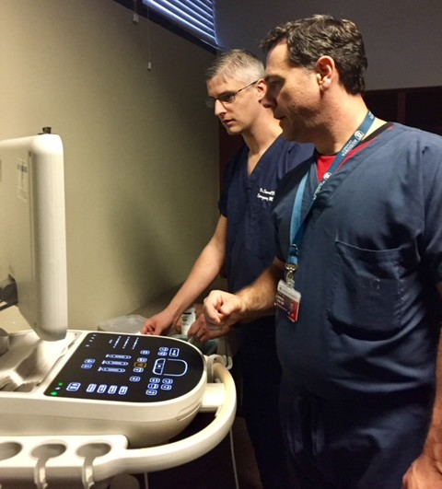Competency Testing: Following completion of the training, residents participate in a CVA cadaver-based competency test. Residents perform the CVA procedure including the CVA bundle in conjunction with a certifying nurse (ED/ICU AUMC nurse). The resident performance is evaluated using a standardized grading rubric by a faculty
physician. The grading rubric is divided into major tasks (failure of a major task results in failure of the competency testing) and minor tasks (a resident passes if he/she does not fail more than 3 minor tasks). Residents must pass the standardized competency evaluation prior to independent
performance of CVA.

Outcomes: In the fall of 2016, all of the GME complement underwent training (GME-wide Grand Rounds) and competency testing. Approximately 30% of the residents failed the competency testing. Those who failed the competency testing were not allowed to perform CVA without direct faculty supervision in the health system. There was an immediate decrease in mechanical complications and CLABSI in the 4th Quarter of 2016. While some of the residents did continue to perform the procedure despite failing the competency testing, CLABSI rates in those who passed the competency testing went to zero by Q1 2017 and have remained zero. There have been no major arterial injuries due to CVA since Q4 2016.

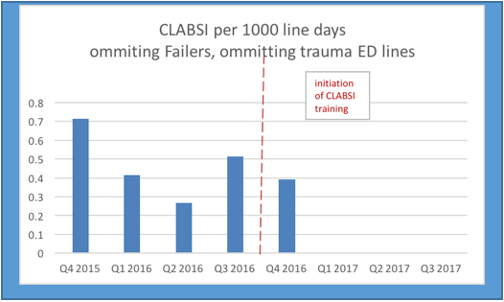Table 1 depicts the CLABSI rate in a normalized fashion (CLABSI / 1000 line days) which is a standard format for reporting the CLABSI rate. The competency testing is indicated by the red dashed line. The mean CLABSI rate prior to competency testing was 0.48 / 1000 line days and after 0.09 / 1000 line days (p=0.003). Table 2 depicts the actual occurrences of CLABSI based on the inserter’s pass or fail in the competency testing.

Table 1: Normalized CLABSI Rate (red line indicated date of initial competency testing)

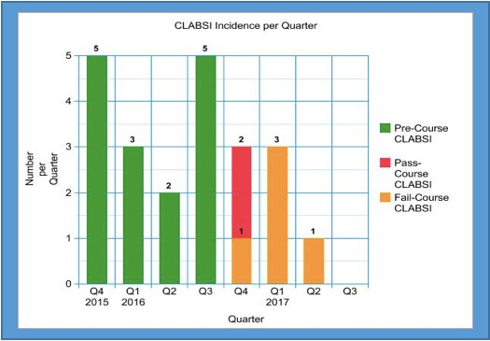T a b l e 2 : C L A B S I Occurrences (absolute instances) – including CLABSI occurrences by residents who failed the competency testing

Cost Analysis: In the 1-year period prior to the MCL SAFER initiative, the quarterly average for CLABSI was 3.75/quarter versus 0.5/quarter in the one year after (with zero CLABSI in the first 3 quarters of 2018). Further, there was 4 major arterial complications in the 12-month period prior to the initiative and zero in the 12-month period after. The AU Health system estimates the cost per infection at $68,000*. With these calculations, the absolute reduction in cost to the system due to the initiative is $884,000 in the year after the initiation of this program.

*Note: Goudie, et al. (Attributable Cost and Length of Stay for Central Line Associated Blood Stream Infections) estimates the mean attributable cost and LOS for CLABSI is $55,646 in 2011 dollars, and 19 days increased LOS. AUMC uses a cost of $68,000/CLABSI. No amount was assigned to the mechanical complication risk reduction

The inaugural year of the Center for Ultrasound Education was an exciting, education filled year touching on all aspects of medical education at the Medical College of Georgia.

In conclusion, the 2016-17 inaugural year of the Center for Ultrasound Education was a successful year - establishment of a center, refinement of the UME curriculum, and initiation of the GME curriculum. This year’s work also resulted in a tangible benefit for the AU Health System, by decreasing complications for resident performed central venous access as well as

aiding in the recruitment of students into the various GME progams, due to the unique ultrasound- related educational content. The 2017-18 year looks to build upon these successes, further developing the curriculum, engaging more participants in learning point of care ultrasound.

