Augusta University Health CF Center News and Resources
- Education Day
Link:
- CF Newsletter
Link
- NACFC
Link
Cystic Fibrosis Foundation
www.cff.org
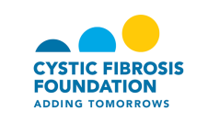

Cystic Fibrosis Services Pharmacy
www.cfservicespharmacy.com

www.cfservicespharmacy.com

Patient Assistance Programs for Medications
www.needymeds.com

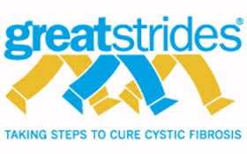
Great Strides
www.cf.org/Great_Strides

CF Specific

- Boomer Esiason Foundation www.esiason.org
- Breathing Room: The art of living with CF www.thebreathingroom.org
- 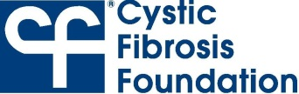 www.cff.org
- Cystic Fibrosis Medicine http://www.cysticfibrosismedicine.com
- 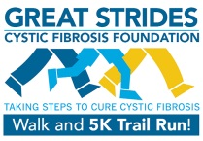 http://www.cff.org/GREAT_STRIDES
- International CF Adult Organization www.iacfa.org
- Medline Plus – Medical Encyclopedia http://www.nim.nig.gov/medlineplus/ency/article/000107.htm
- National Library of Medicine http://ghr.nlm.nih.gov/condition=cysticfibrosis
- Cystic-L www.cystic-l.org

Support Groups/Support
- National Parent-to-Parent Network www.netnet.net/mums

Transplantation and Organ Donation
- All About Transplantation and Donation www.transweb.org
- American Organ Transplant Association http://aota.schipul.net
- Dept. of Health & Human Services www.organdonor.gov
- UNOS (United Network for Organ sharing) http://www.unos.org

Fun Resources Just for Kids
- Math Topics www.gomath.com
- Geared for elementary & middle school
Students www.factmonster.com
- Homework help site www.homeworktips.about.com/mbody.htm
- Public Broadcasting system www.pbs.org/kids
- Kidlink www.kidlink.org
- How Stuff Works www.howstuffworks.com
- National Geographic for Kids www.nationalgeographic.dom/kids
- Crayola Kids www.crayola.com
- Kids domain www.kidsdomain.com/kids.html

Link: Physician: journals, research, etc.
http://www.cff.org/research/ClinicalResearch/Participate
Link: Nursing: education, news, etc.
Link: Nutrition: recipes; journals, etc.
Link: Respiratory: ACT, equipment, etc.
Link: Social work: patient assistance, etc.

