DID YOU KNOW?
MCG Community Faculty…
Are in the majority for who teaches
MCG’s medical students?
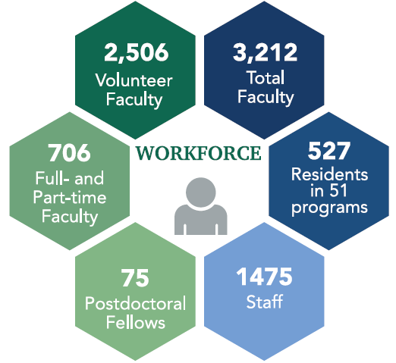
Can access a variety of teacher development resources at the Medical Educator Minute page? (https://bit.ly/2GyL3Bn)


Can access grand rounds information from the CME office, and online journals via AU’s Greenblatt Library?
Are eligible for promotion in rank based on years of teaching and number of
students taught? Contact your regional campus leadership or clerkship director/coordinator for more details.

.

1.

2

3

4

Clerkship Coordinator Track
FRIDAY, MAY 31st | 9:15 AM – 12:00 PM | Oceanside #1
- Coordinator Perks
- Clerkship Breakout Sessions

SATURDAY, JUNE 1st | 8:15 AM – 12:00 PM | Oceanside #1
- Clerkship Wellness
- Build Bridges, Not Walls

Facilitators: Dayna Seymore, BA, Shannon Black, BA, Matthew Homen, BS

This activity has been planned and implemented in accordance with the accreditation requirements and policies of the Accreditation Council for Continuing Medical Education (ACCME) through the joint providership of Southeast Georgia Health System and Augusta University. Southeast Georgia Health System is accredited by the Medial Association of Georgia to provide continuing medical education for physicians. Southeast Georgia Health Systems designates this educational activity for a maximum of 11 AMA PRA CAT 1 credits(s)TM. Physicians should claim only the credit commensurate with the extent of their participation in the activity.

For the full agenda and additional information on MCG’s 2019 Annual Statewide Faculty Development Conference, visit our website:

https://bit.ly/2TOPEmG


Save the date
for next year’s conference!
June 4-6, 2020



2019 Statewide Faculty Development Conference



Teaching Tomorrow’s Physicians Today:
MCG’s Mission for Georgia

May 30 - June 1, 2019
Jekyll Island, Georgia
Jekyll Island Convention Center

THURSDAY, MAY 30th
4:00 – 6:00 PM
Educational Session with Clerkship Emphasis
– Oceanside Salon #6
• MCG Medical Education Highlights – Doug Miller, MD
• Positive Learning Environment & Title IX
– Chris Melcher, JD
• Faculty Development Highlights – Ralph Gillies, PhD

6:00 - 7:00PM | Cocktail Reception with music by the Bristol Family Band

7:00PM | Dinner

FRIDAY, MAY 31st
7:15 - 8:00 AM
Breakfast and Registration

8:00 - 8:15AM
Welcome & Conference Overview
Kathryn Martin, PhD & Ralph Gillies, PhD
Special welcome by Michael Scherneck, MS,
President and CEO of Southeast Georgia Health System

8:15 - 9:00AM | Plenary Session:
Medical Education at MCG Today & Tomorrow - Doug Miller, MD, Vice Dean for Academic Affairs
9:00 - 9:15 AM | Break

9:15 – 10:00 AM| Concurrent Sessions:
• Providing Effective Verbal Feedback – Oceanside #4
Gerald Crites, MD, MEd & Vicki McKinney, PhD
• Using Technology at the Bedside – Oceanside #5
Julie K. Gaines, MLIS, AHIP, Ed Sperr, MLIS, AHIP &
Flint Buchannan, MFA, MEd
• Identifying and Assisting the Struggling Learner – Oceanside #6 | Scott Richardson, MD

10:00 – 10:15 AM | Break

FRIDAY, MAY 31st - continued

10:15 – 11:00 AM | Repeat: 9:15 AM Concurrent Sessions

11:00 – 11:15 AM | Break

11:15 – 12:00 PM: Breakout Sessions by Region:
• Oceanside #1: WellStar • Oceanside #4: Northwest
• Oceanside #2: Southwest • Oceanside #5: Athens
• Oceanside #3: Southeast • Oceanside #6: Augusta

11:45 – 12:30 PM | Tech Support in Lobby with JoAnn Edmond, MS, MCG Instructional Analyst
• Accessing library services • Installing Duo authentication
• Accessing STFM Teaching Physicians online subscription
• Accessing MCG grand rounds

12:00 PM – Lunch line-up

12:15 - 1:15PM
Lunch & Learn: MCG Medical Education Quick Shots:
Moderator: Renee Page, MD, Associate Dean for Curriculum

1:15 – 5:30PM
Free time! Enjoy what Jekyll Island has to offer. See the information board in the lobby to learn about activities on your own or with a group!

5:30- 6:30 PM | Cocktail Reception
• Display table: Simulation via Long-Distance
– Matthew Tews, DO, MS

6:30PM | Dinner & Awards Ceremony:
•Welcome – Shelley Nuss, MD, AU/UGA Medical
Partnership Dean
• MCG Update – David Hess, MD, MCG Dean
• Recognition and Awards – Kathryn Martin, PhD
& Matthew Homen, BA

SATURDAY, JUNE 1st
7:15 - 8:00AM
Breakfast and Registration

8:00 – 8:15 AM
Welcome & Overview | K. Martin, PhD & R. Gillies, PhD

SATURDAY, JUNE 1st - continued

8:15 – 9:00 AM | Large Group Session:
From MCG Medical Student to Georgia Physician: Success Stories of Our Regional Campus Model. Moderated by Doug Patten, MD, Southwest Campus Dean

9:00 – 9:15 AM | Break

9:15 – 10:00 AM | Concurrent Sessions:
• Telesimulation: Simulation at a Distance for Clerkship Students – Oceanside #4 | Matthew Tews, DO, MS & Eric Zevallos, MD
• Unconscious Bias in Academic Medicine: Impact of What We Don’t Know on Medical Teaching and Practice – Oceanside #5 | Winston Price, MD
• Teaching & Working with Learners at Different Levels – Oceanside #6 | Kathryn McLeod, MD
10:00 – 10:15 AM | Break

10:15 – 11:00 AM | Repeat: 9:15 AM Concurrent Sessions

11:00 – 11:15 AM | Break
11:15 AM – 12:00 PM | Breakout Session by Specialty
• Oceanside #1: Obstetrics & Gynecology
• Oceanside #2: Pediatrics
• Oceanside #3: Family Medicine
• Oceanside #4: Surgery
• Oceanside #5: Medicine
• Oceanside #6: Ambulatory Medicine, Emergency Medicine, Neurology, Psychiatry

12:00 PM – Lunch line-up

12:15 - 1:15 PM
Lunch & Learn: MCG Impacting Georgia Communities
Opening comment by Denise D. Kornegay, MSW, MCG Associate Dean for AHEC; Georgia Statewide Network Executive Director
Moderated by Wayne Rentz, MD, Dean for Curriculum, Southeast Campus

1:15 – 1:30 PM | Closing Remarks & Conference Evaluation | R. Gillies, PhD & K. Martin, PhD

